June 14, 2026 Liturgist: Terry Crickenberger

PRELUDE Allemande, Courante Mattheson (1681-1764)

WELCOME & ANNOUNCEMENTS

INTROIT Rejoice, Ye Pure in Heart Dirksen (1921-2003)

CALL TO WORSHIP
Leader: The Lord hears us when we cry out.
All: Praise the Lord!
Leader: The Lord showers us with blessings.
All: Praise the Lord!
Leader: Let us lift up the name of Lord for all to hear!
All: Praise the Lord!
Leader: Let us sing of God’s endless grace and compassion!
All: Let us worship God!

MORNING PRAYER

*OPENING HYMN #655 What Shall I Render to the Lord MARTYRDOM

CHILDREN’S SERMON

CALL TO CONFESSION

PRAYER OF CONFESSION (based on Romans 5)
Loving God, we come with heavy hearts. We have not lived as you have called us to live. We give up too easily. We ignore our neighbors’ cries for help. We fail to meet injustice head-on. We lose hope. We do not see your blessings among us, and we are blind to the glimpses of the kingdom all around us. We are weak. Have mercy upon us. Shower us with your grace that we might be enlivened for service and for love. Lord, hear our prayer… Amen.

SILENT PRAYER

ASSURANCE OF PARDON

*GLORIA PATRI #581 Glory Be to the Father GLORIA PATRI

FIRST SCRIPTURE LESSON Psalm 116

SPECIAL MUSIC Caprice Gottlieb Muffat (1690-1770)

GOSPEL READING Matt. 13:45-46

SERMON One Very Precious Pearl Rev. Samantha Coggins

*AFFIRMATION OF FAITH (Question 21 of the Heidelberg Catechism) What is true faith?
True faith is not only a sure knowledge by which I hold as true all that God has revealed to us in Scripture; it is also a wholehearted trust, which the Holy Spirit creates in me by the gospel, that God has freely granted, not only to others but to me also, forgiveness of sins, eternal righteousness, and salvation. These are gifts of sheer grace granted solely by Christ’s merit. Glory be to the Father, and to the Son, and to the Holy Spirit. Amen.

PRAYERS of the PEOPLE and THE LORD’S PRAYER

*CLOSING HYMN #20 All Things Bright and Beautiful ROYAL OAK

*BENEDICTION

POSTLUDE Toccata Georg Muffat (1653-1704)

Today’s liturgy is written by Rae Watson and the Presbyterian Outlook. Rae is the Associate Pastor at Covenant Presbyterian Church in Staunton.



LINK: https://www.youtube.com/watch?v=tzBPhTAo_pk

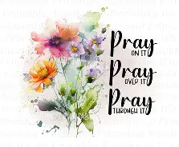

The Legacy At North Augusta: Joyce Tipton

Home: Mary Ultee, Mary Ann Maupin, Warner Sandquist, Polly Bare, Linda Quillen, Olive Prettyman, Nancy Hypes.

Friends and Family: Carolyn Hedrick-Williams (Colleen Cash), Damon Prettyman (Olive Prettyman).

Military: Carson Craig, Michael Little

New Members Classes

We will continue to have New Members Class on the following Sundays: June 21, July 5 and July 19. We meet in the Barksdale Room at 9:00 a.m.
Those who would like to join the church are invited to do so during worship on Sunday, August 16.

An offering plate is available in the narthex.

FIRST PRESBYTERIAN CHURCH
WAYNESBORO, VIRGINIA

A community-minded congregation living out the love of Christ as we serve one
another with humility, gentleness, and patience through God’s grace.

June 14, 2026 11:00 AM

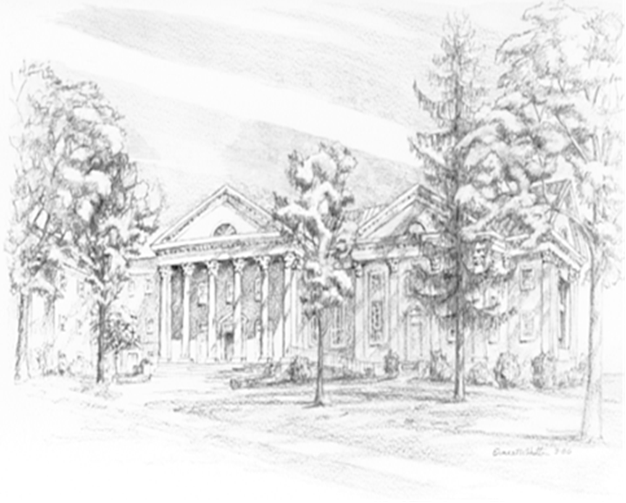

P.O. Box 877
249 South Wayne Avenue
Waynesboro, Virginia
(540) 949-8366
Church Website: www.firstpresway.org
Preschool Website: www.firstprespre.org
Email: church@firstpresway.com

