June 21, 2026 Liturgist: Patrick Fitzgibbon

PRELUDE Sonata in A-flat, H. 31: I CPE Bach (1714-1788)

WELCOME & ANNOUNCEMENTS

INTROIT O Come, Let Us Sing Unto the Lord Lantz III (b. 1956)

O come, let us sing unto the Lord.
Let us come into His presence with joyful thankgiving:
O come, let us sing unto the Lord.
Sing to the Lord, all those on earth. Bless His Name!

CALL TO WORSHIP
Leader: Not one sparrow will fall to the ground apart from their Creator.
All: God tells us we are of more value than many sparrows.
Leader: God knows us and loves us. Even the hairs of our head are all counted.
All: We praise you, O God! Grateful are we for your love and care.

MORNING PRAYER

*OPENING HYMN #169 Dear Lord and Father of Mankind REST

CHILDREN’S SERMON

CALL TO CONFESSION

PRAYER OF CONFESSION
You send us, God of the Great Commission, but we hedge and hesitate. Forgive our fear and our excuses. We are witnesses of your grace and glory but allow others to silence our praise. We imprison ourselves with doubt and shame and fail to shine your light for all to see. Forgive our fears. Free our testimony. Help us be your faithful disciples. Amen.

SILENT PRAYER

ASSURANCE OF PARDON

*GLORIA PATRI #581 Glory Be to the Father GLORIA PATRI

FIRST SCRIPTURE LESSON Psalm 86 p. 473

ANTHEM A Song of Praise Rutter (b. 1945) Maximilian Daggy, baritone

Glory to you, Lord God of our fathers; you are worthy of praise; glory to you.
Glory to you for the radiance of your holy Name; we will praise you & highly exalt you forever.
Glory to you in the splendor of your temple; on the throne of your majesty, glory to you.
Glory to you, seated between the Cherubim; we will praise you and highly exalt you forever.
Glory to you, beholding the depths; in the high vault of heaven, glory to you.
Glory to you, Father, Son and Holy Spirit; we will praise you and highly exalt you forever.

GOSPEL READING Proverbs 8:22-31 p. 515

SERMON Wisdom’s Autobiography Rev. Samantha Coggins

*AFFIRMATION OF FAITH Apostles’s Creed p. 35

PRAYERS of the PEOPLE and THE LORD’S PRAYER

*CLOSING HYMN #435 There’s A Wideness in God’s Mercy IN BABILONE

*BENEDICTION

POSTLUDE Pastorale IV, BWV 590 JS Bach (1685-1750 )

This morning’s liturgy is written by Teri McDowell Ott and the Presbyterian Outlook.

LINK: https://www.youtube.com/watch?v=IYQiP9K6uoM




The Legacy At North Augusta: Joyce Tipton

Home: Mary Ultee, Mary Ann Maupin, Warner Sandquist, Polly Bare, Linda Quillen, Olive Prettyman, Nancy Hypes, Ruth & Lewis Kelley.

Friends and Family: Carolyn Hedrick-Williams (Colleen Cash), Damon Prettyman (Olive Prettyman).

Military: Carson Craig, Michael Little

New Members Classes

We will continue to have New Members Class on the following Sundays: July 5 and July 19. We meet in the Barksdale Room at 9:00 a.m.
Those who would like to join the church are invited to do so during worship on Sunday, August 16.
Book Signing-Bernadette Griffith
Saturday, June 27, at 11am
In the Barksdale Room

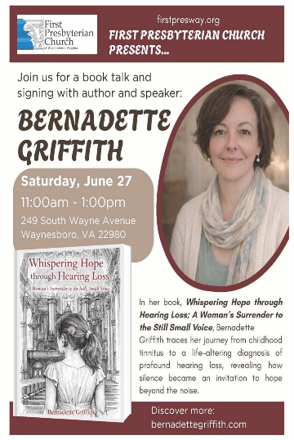
Bernadette will share about her book,
“Whispering Hope Through Hearing Loss: A Woman’s Surrender to the Still, Small, Voice.”
Bernadette is married to Mike Griffith, FPC’s building maintenance manager.

An offering plate is available in the narthex.
FIRST PRESBYTERIAN CHURCH
WAYNESBORO, VIRGINIA

A community-minded congregation living out the love of Christ as we serve one
another with humility, gentleness, and patience through God’s grace.

June 21, 2026 11:00 AM

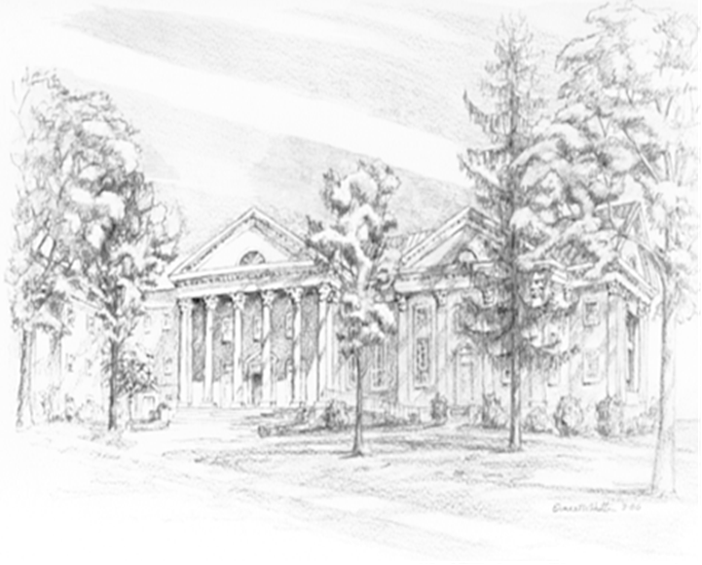

P.O. Box 877
249 South Wayne Avenue
Waynesboro, Virginia
(540) 949-8366
Church Website: www.firstpresway.org
Preschool Website: www.firstprespre.org
Email: church@firstpresway.com

