June 7, 2026 Liturgist: Joe Earhart

PRELUDE Fugue Clérambault (1676-1749)

WELCOME & ANNOUNCEMENTS

INTROIT Alleluia Milburn (b. 1963)

CALL TO WORSHIP
Leader: Rejoice in the Lord! Praise the Lord with instruments and shouts of joy!
All: God loves justice and righteousness. The earth is full of God’s love.
Leader: Let all of creation revel in awe of God, our creator.
All: God’s love endures forever.
Leader: Amen! Let us worship together.

MORNING PRAYER

*OPENING HYMN #65 Guide Me, O Thou Great Jehovah CWM HONDDA

CHILDREN’S SERMON

CALL TO CONFESSION

PRAYER OF CONFESSION
Holy God, we confess, a bit pridefully, that we appreciate decency and order, forgetting that we seek the order that is of our own making. We confess that clear rules and social norms give us comfort, forgetting how many of your beloved children are hurt and excluded by them. We confess that we place our trust in ability, strength, and the works we produce, forgetting our total reliance on your grace. Forgive us, God, and free us to live in courageous faith, that we may abide in your righteousness. Amen.

SILENT PRAYER

ASSURANCE OF PARDON

*GLORIA PATRI #581 Glory Be to the Father GLORIA PATRI

OLD TESTAMENT READING Genesis 12:1-9 p.8

ANTHEM Draw Us in the Spirit’s Tether Friedell (1905-1958)
(text can be found in hymn 529)
SECOND READING Psalm 139 p.503

SERMON Where Can I Flee From Your Spirit? Rev. Samantha Coggins

*AFFIRMATION OF FAITH (from A Declaration of Faith)
We hold that what God says to us and does for us centers in Jesus Christ, our living Lord as he is remembered, known, and expected. In Christ, God’s Word of acceptance takes flesh:
by grace through faith we are set right with God, adopted as children of God,
not because of anything we have done, but because of what Christ has done.
In Christ, God’s Word of demand is lived out: to love God and neighbor as Jesus did
is what God requires of us. The Spirit adds no different Word from God, but leads us deeper
into the truth of God uttered in Jesus Christ.

THE LORD’S SUPPER
Invitation
Great Thanksgiving
Communion of the People

*CLOSING HYMN #738 O Master, Let Me Walk with Thee MARYTON

*BENEDICTION

POSTLUDE Concerto in G: Presto Ernst (1696-1715)
Bach (1685-1750)
Today’s liturgy is written by Stephanie Sorge and the Presbyterian Outlook. Stephanie is the pastor of Trinity Presbyterian Church in Harrisonburg, VA.

LINK https://www.youtube.com/watch?v=0Aj9xm2_4uA

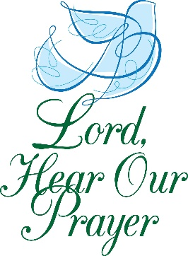

Legacy at North Augusta : Joyce Tipton

Summit Square : Ruth Quillen

Home: Mary Ultee, Mary Ann Maupin, Warner Sandquist, Polly Bare, Olive Prettyman, Nancy Hypes, Mike and Cathy Cunningham, Linda Quillen.

Friends and Family: Carolyn Hedrick-Williams (Colleen Cash), Betsy Boswell (Curry), Damon Prettyman (Olive Prettyman), Jessica Faulk, Maria Costello (Cunningham).

Military: Carson Craig, Michael Little

Food Bank food & fellowship this Thursday, June 11! We will gather around 4:45-5:00 pm, after we serve in the pantry. See Samantha or Cynthia Hoover for details.

Summer Book Study begins Wednesday, July 8, at 10:00 a.m. If you would like to be added to the e-mail list, please see Samantha.

FIRST PRESBYTERIAN CHURCH
WAYNESBORO, VIRGINIA

A community-minded congregation living out the love of Christ as we serve one another with humility, gentleness, and patience through God’s grace.

June 7, 2026 11:00 AM

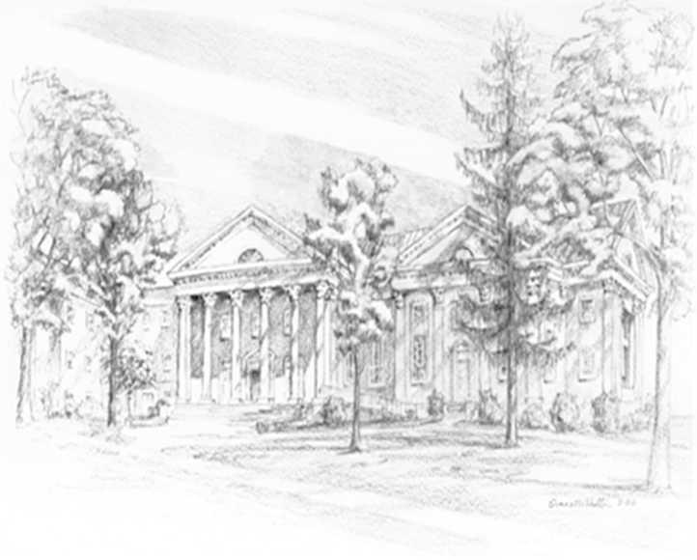

P.O. Box 877
249 South Wayne Avenue
Waynesboro, Virginia
(540) 949-8366
Church Website: www.firstpresway.org
Preschool Website: www.firstprespre.org
Email: church@firstpresway.com

