July 12, 2026 Liturgist: Kimberlea Daggy

PRELUDE Prelude in g, BWV 535 Bach (1685-1750)

WELCOME & ANNOUNCEMENTS

INTROIT Alleluia Milburn (b. 1963)

CALL TO WORSHIP
Leader: All who walk in shadow, come into the light!
All: God’s Word lights the way for us.
Leader: God has promised to abide with us.
All: So let us commit to walk in God’s ways.
Leader: All who are afflicted, ensnared by the world, come give praise to God.
All: God is the joy of our heart, our sure and certain comfort, come what may.

MORNING PRAYER

*OPENING HYMN #14 For the Beauty of the Earth DIX

CHILDREN’S SERMON

CALL TO CONFESSION

PRAYER OF CONFESSION
Gracious Creator, you created this world and called it good, and out of it called a pilgrim people, chosen to abide with you and to bear witness to your reality. Yet we, who have been called beloved by you, often find ourselves making peace with what does not give peace. Meet us in our weakness; turn our unwilling eyes upon our unruly hearts. Draw us away from our love of power, our tolerance of injustice, our ignorance of suffering. Drive us towards what is fearfully and wonderfully made, so that we may inspire hope, offer forgiveness, and love our neighbors through faithful living, according to the way of Jesus Christ, in whose name we pray. Amen.

SILENT PRAYER

ASSURANCE OF PARDON

*GLORIA PATRI #581 Glory Be to the Father GLORIA PATRI

FIRST SCRIPTURE READING Psalm 65 p. 459

ANTHEM The Call Vaughan Williams (1872-1958)
Terry Crickenberger, tenor

Come, my Way, my Truth, my Life:
Such a Way, as gives us breath:
Such a Truth, as ends all strife: Such a Life, as killeth death.

Come, My Light, my Feast, my Strength:
Such a Light, as shows a feast:
Such a Feast, as mends in length: Such a Strength, as makes his guest.

Come, my Joy, my Love, my Heart:
Such a Joy, as none can move:
Such a Love, as none can part: Such a Heart, as joys in love.

SECOND READING Ruth 1:8-22 p. 210

SERMON Lifeguards Rev. Samantha L. Coggins

*AFFIRMATION OF FAITH The Apostles’ Creed Hymnal p.35

PRAYERS of the PEOPLE and THE LORD’S PRAYER

*CLOSING HYMN #726 Will You Come and Follow Me Kelvingrove

*BENEDICTION

POSTLUDE Fugue in g, BWV 535 Bach

This week’s liturgy is written by Rev. Dr. Aaron Shepherd & the Presbyterian Outlook.

Link: https://www.youtube.com/watch?v=w7mmjCb3q8A


The Legacy At North Augusta: Joyce Tipton

Home: Mary Ultee, Mary Ann Maupin, Warner Sandquist, Polly Bare, Linda Quillen, Olive Prettyman, Nancy Hypes, Ruth & Lewis Kelley.

Friends and Family: Carolyn Hedrick-Williams (Colleen Cash), Damon Prettyman (Olive Prettyman), Carol Perkins.

Military: Carson Craig, Michael Little

New Members Classes
We will have one more New Members’ class next Sunday, July 19. All who have attended, at any point over the past two months, are welcome. New members will join the church on Sunday, August 16. If you plan to join, please be sure to tell Samantha, if you have not already.

Summer Book Study has begun
We meet again for discussion of Jeff Chu’s Good Soil this Wednesday, July 15, at 10:00 a.m. in the Barksdale Room. In preparation, please read to page 82, through the section called Winter. If you’d still like a copy of the book, or to be added to the e-mail list, please contact Samantha.


FOOD BANK
Almost that time again, The Food Bank is looking for donations of:
Pencils
Pens
Glue sticks
Scissors
Crayons
Erasers
Spiral notebooks


An offering plate is available in the narthex.
FIRST PRESBYTERIAN CHURCH
WAYNESBORO, VIRGINIA

A community-minded congregation living out the love of Christ as we serve one
another with humility, gentleness, and patience through God’s grace.

July 12, 2026 11:00 AM

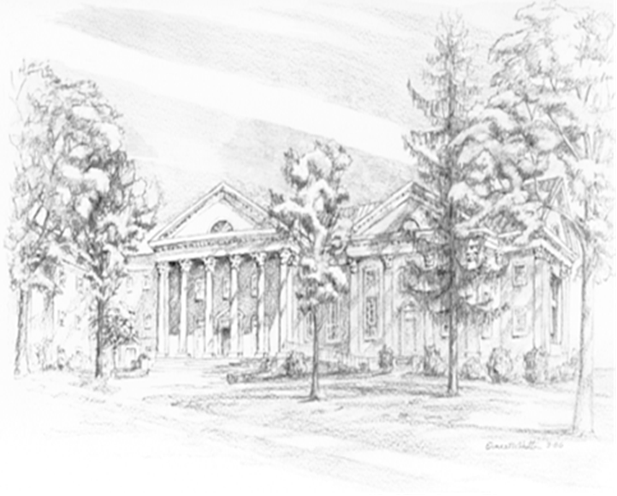

P.O. Box 877
249 South Wayne Avenue
Waynesboro, Virginia
(540) 949-8366
Church Website: www.firstpresway.org
Preschool Website: www.firstprespre.org
Email: church@firstpresway.com

