July 19, 2026 Liturgist: Terry Crickenberger

PRELUDE Concerto in D Minor Giuseppi Torelli, 1658-1709
arr. Johann Walther, 1684-1748

WELCOME & ANNOUNCEMENTS

INTROIT The Voice of Peace Lani Smith, 1934-2015

CALL TO WORSHIP
Leader: Surely the Lord is in this place, and we did not know it.
All: We do not know when and where God’s glorious presence will show up.
Leader: Surely, we are the Body of Christ.
All: We cannot say to one another, “I have no need of you.”
Leader: Surely our God is a mystery that cannot be contained.
All: Let us worship our unpredictable and uncontrollable God!

MORNING PRAYER

*OPENING HYMN #804 Rejoice, Ye Pure in Heart MARION

CHILDREN’S SERMON

CALL TO CONFESSION

PRAYER OF CONFESSION
Lord, you have searched us and found us wanting. You have known our inmost thoughts and called us to better things. You have set us in this world to love and serve you by loving and serving one another, to worship you by tending to those most vulnerable among us.
When we fail, do not abandon us. When we go astray, call us back home.
Search us, O God, and know our hearts. Test us and know our thoughts. Root out the wicked ways in us and lead us in the way everlasting. Amen.

SILENT PRAYER

ASSURANCE OF PARDON

*GLORIA PATRI #581 Glory Be to the Father GLORIA PATRI

FIRST SCRIPTURE READING Psalm 119:1-32 p.493

SPECIAL MUSIC Basso Ostinato from Suite, Opus 92 Max Reger 1873-1916

GOSPEL READING Matthew 5:1-12 p. 785

SERMON Happy People Rev. Samantha L. Coggins

*AFFIRMATION OF FAITH (from the Second Helvetic Confession)
The Church is an assembly of the faithful, Called or gathered out of the world.
They are all citizens of the one city, Living under the same Lord,
Under the same laws, And in the same fellowship with all good things.
Those who are in the Church have one faith and one spirit;
They worship but one God, And in God alone they worship in spirit and truth.
Hence, we must be very careful not to judge before the time,
Nor undertake to exclude, reject, or cut off Those whom the Lord does not want to have excluded or rejected, And those whom we cannot eliminate without loss to the Church.

PRAYERS of the PEOPLE and THE LORD’S PRAYER

*CLOSING HYMN #389 Blessed Assurance ASSURANCE

*BENEDICTION

POSTLUDE Allegro from the Eighth Organ Concerto G. F. Handel, 1685-1759

Link: https://www.youtube.com/watch?v=3Tlgt9w4v2o

We gladly welcome our guest organist, Diane Kingsbury, to our sanctuary this morning. Diane has graciously helped us on numerous occasions over the years, and we are most grateful to her for providing music for our worship service this morning.

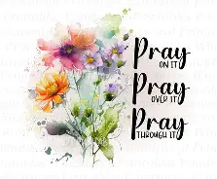

The Legacy At North Augusta: Joyce Tipton

Home: Mary Ultee, Mary Ann Maupin, Warner Sandquist, Polly Bare, Linda Quillen, Olive Prettyman, Nancy Hypes, Ruth & Lewis Kelley.

Friends and Family: Carolyn Hedrick-Williams (Colleen Cash), Damon Prettyman (Olive Prettyman), Carol Perkins.

Military: Carson Craig, Michael Little

New Members Classes
New members will join the church on Sunday, August 16. If you plan to join, please be sure to tell Samantha, if you have not already.

Summer Book Study has begun
We meet again for discussion of Jeff Chu’s Good Soil this Wednesday, July 22, at 10:00 a.m. in the Barksdale Room. In preparation, please read to page 126 (through the Spring Section)


FOOD BANK
Almost that time again, The Food Bank is looking for donations of:
Pencils
Pens
Glue sticks
Scissors
Crayons
Erasers
Spiral notebooks


An offering plate is available in the narthex.

FIRST PRESBYTERIAN CHURCH
WAYNESBORO, VIRGINIA

A community-minded congregation living out the love of Christ as we serve one
another with humility, gentleness, and patience through God’s grace.

July 19, 2026 11:00 AM

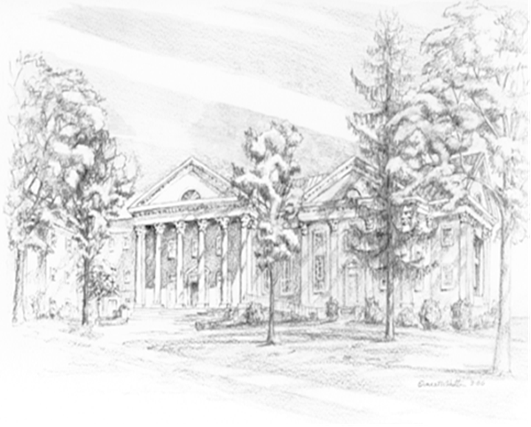

P.O. Box 877
249 South Wayne Avenue
Waynesboro, Virginia
(540) 949-8366
Church Website: www.firstpresway.org
Preschool Website: www.firstprespre.org
Email: church@firstpresway.com

