July 26, 2026 Liturgist: Betsy Ruehl

PRELUDE Nocturne, Op. 35, no. 10 Glière (1875-1956)
Jacob Wilder, horn

WELCOME & ANNOUNCEMENTS

INTROIT Deo Gracias circa 1415

CALL TO WORSHIP
Leader: What is music to God’s ears?
All: Not our own festivals or assemblies…
Leader: but justice, rolling down like waters,
All: and righteousness, like an ever-flowing stream.

MORNING PRAYER

*OPENING HYMN #267 Come, Christians, Join to Sing MADRID

CHILDREN’S SERMON

CALL TO CONFESSION

PRAYER OF CONFESSION
God of grace, we want to understand what the kingdom of heaven is like, but our minds are clouded by cares and concerns of the world. We fail to trust your power, hidden in all things. We fail to watch for you, working out your purposes in mysterious ways. We fail to be whole-hearted in our faith and discipleship. We fail to put our trust in the treasures of your kingdom instead of the treasures of the world. Gracious God, hidden and manifest, give us eyes to see and ears to hear your good news for the world, even here and now. Transform our lives and our world by your grace.

SILENT PRAYER

ASSURANCE OF PARDON

*GLORIA PATRI #581 Glory Be to the Father GLORIA PATRI

FIRST SCRIPTURE READING Psalm 105:1-11 p. 484

SPECIAL MUSIC Andante in E-flat, Op. 35, no. 6 Glière
Jacob Wilder, horn

GOSPEL READING Amos 5:18-24 p. 747

SERMON Divine Disgust Rev. Samantha L. Coggins

*AFFIRMATION OF FAITH The Apostle’s Creed Hymnal p.35

PRAYERS of the PEOPLE and THE LORD’S PRAYER

*CLOSING HYMN #33 Praise the Lord! God’s Glories Show LLANFAIR

*BENEDICTION

POSTLUDE Grand Jeu Clérambault (1676-1749)

This week’s liturgy is written by Matthew A. Rich and the Presbyterian Outlook.

Link: https://www.youtube.com/watch?v=Ibwk7MoZWV4

This morning we welcome Jacob Wilder, who currently serves as Principal Horn of the Virginia Symphony Orchestra and the Wintergreen Summer Festival Orchestra. Jacob completed a Bachelor of Music and an Artist Diploma in French Horn performance at the Colburn Conservatory of Music in downtown Los Angeles. While in LA, Jacob played substitute horn with the Los Angeles Philharmonic, Wisconsin Chamber Orchestra and the Santa Barbara Symphony. When he’s not making music, Jacob enjoys being outdoors biking, hiking or playing basketball. We are so grateful to Jacob for sharing his musical gifts with us this morning!



Summit Square: Ruth Quillen

Home: Mary Ultee, Mary Ann Maupin, Warner Sandquist, Polly Bare, Linda Quillen, Olive Prettyman, Nancy Hypes, Ruth & Lewis Kelley.

Friends and Family: Carolyn Hedrick-Williams (Colleen Cash), Damon Prettyman (Olive Prettyman), Carol Perkins.

Military: Carson Craig, Michael Little

Our Christian sympathies to the family of Joyce Tipton who passed on Saturday July 18. A memorial service will be held here August 2, following the Worship service, at 12:30 pm.

New Members Classes
New members will join the church on Sunday, August 16. If you plan to join, please be sure to tell Samantha, if you have not already.

Summer Book Study
We meet again for discussion of Jeff Chu’s Good Soil Wednesday, August 5, at 10:00 a.m. in the Barksdale Room. In preparation, please read through the Summer section(ending with Heron)

FOOD BANK
Almost that time again, The Food Bank is looking for donations of:
Pencils
Pens
Glue sticks
Scissors
Crayons
Erasers
Spiral notebooks


An offering plate is available in the narthex.

FIRST PRESBYTERIAN CHURCH
WAYNESBORO, VIRGINIA

A community-minded congregation living out the love of Christ as we serve one
another with humility, gentleness, and patience through God’s grace.

July 26, 2026 11:00 AM

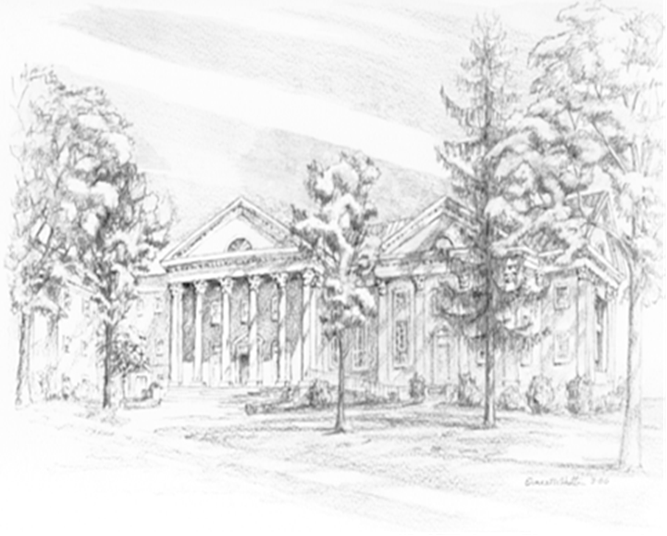

P.O. Box 877
249 South Wayne Avenue
Waynesboro, Virginia
(540) 949-8366
Church Website: www.firstpresway.org
Preschool Website: www.firstprespre.org
Email: church@firstpresway.com

