July 5, 2026 Liturgist: Joe Earhart

PRELUDE The Star-Spangled Banner Smith (1750-1836)
arr. Line (b. 1958)
Sarah Braverman, piano

WELCOME & ANNOUNCEMENTS

INTROIT Deo Gracias circa 1415

CALL TO WORSHIP
Leader: Come and fill our hearts with your peace, God.
All: You alone, O Lord, are holy.
Leader: Come and fill our hearts with your peace, God.
All: Alleluia!

MORNING PRAYER

*OPENING HYMN #337 My Country, ‘Tis of Thee AMERICA

CHILDREN’S SERMON

CALL TO CONFESSION

PRAYER OF CONFESSION
God of the road, we confess that we have walked away: from the hard work of reconciliation, from communities that needed our presence, from the stranger walking beside us whose questions we were too tired to hear. Forgive us. Meet us on this road. Open our eyes to recognize you. And when you feed us, turn us around. In the name of the one who is always, impossibly, already on the road beside us, we pray. Amen.

SILENT PRAYER

ASSURANCE OF PARDON

*GLORIA PATRI #581 Glory Be to the Father GLORIA PATRI

OLD TESTAMENT READING Psalm 145 p.506

ANTHEM Be Not Afraid Dufford (b. 1943)
arr. Hayes (b. 1953)
Sarah Braverman, piano

SECOND READING Luke 24:13-35 p. 860

SERMON On The Road Again Rev. Samantha Coggins

*AFFIRMATION OF FAITH (from the Barmen Declaration)
As Jesus Christ is God’s assurance of the forgiveness of all our sins, so in the same way and with the same seriousness is he also God’s mighty claim upon our whole life. Through him befalls us a joyful deliverance from the godless fetters of this world for a free, grateful service to his creatures. We reject the false doctrine, as though there were areas of our life in which we would not belong to Jesus Christ, but to other lords — areas in which we would not need justification and sanctification through him.

THE LORD’S SUPPER
Invitation
Great Thanksgiving
Communion of the People

*CLOSING HYMN #338 O Beautiful for Spacious Skies MATERNA

*BENEDICTION

POSTLUDE National Anthem Smith

This week’s prayers are from the morning worship service held at the 227th General Assembly of the PCUSA, at the Baird Center in Milwaukee, WI, on Monday, June 29.

LINK https://www.youtube.com/watch?v=aSNZZPAYVnI

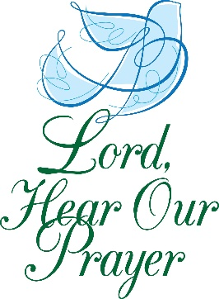

Legacy at North Augusta : Joyce Tipton

Summit Square : Ruth Quillen

Home: Mary Ultee, Mary Ann Maupin, Warner Sandquist, Polly Bare, Olive Prettyman, Nancy Hypes, Mike and Cathy Cunningham, Linda Quillen.

Friends and Family: Carolyn Hedrick-Williams (Colleen Cash), Betsy Boswell (Curry), Damon Prettyman (Olive Prettyman), Jessica Faulk, Maria Costello (Cunningham).

Military: Carson Craig, Michael Little

This morning, we welcome Sarah Braverman, who maintains a private piano studio in Fishersville. She earned a Bachelor of Music in Piano Performance from Illinois Wesleyan University, including a semester abroad in Vienna studying music. She received both a Master of Music in Piano Performance and a Post-Baccalaureate Certificate in Music Theory from the University of North Carolina at Greensboro. Ms. Braverman hosts piano recitals for her students at FPC twice a year. We are grateful to her for sharing her time and talents today with our congregation!

Summer book study on Good Soil by Jeff Chu begins this Wednesday, July 8, at 10:00 a.m. Please read through the ‘Autumn’ section (ending with ‘dog’), which is around page 52 in most editions of the book. If you would like to be added to the e-mail list, please see Samantha.


FIRST PRESBYTERIAN CHURCH
WAYNESBORO, VIRGINIA

A community-minded congregation living out the love of Christ as we serve one another with humility, gentleness, and patience through God’s grace.

July 5, 2026 11:00 AM

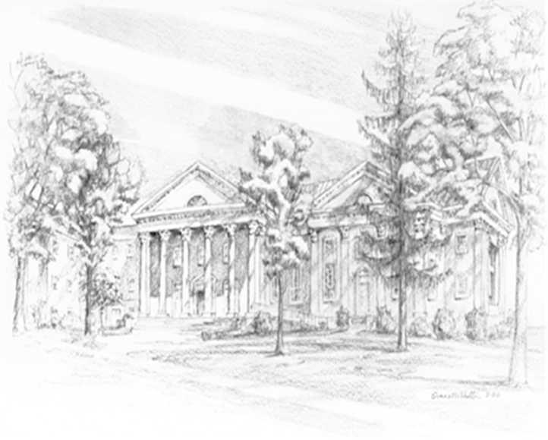

P.O. Box 877
249 South Wayne Avenue
Waynesboro, Virginia
(540) 949-8366
Church Website: www.firstpresway.org
Preschool Website: www.firstprespre.org
Email: church@firstpresway.com

