June 28, 2026 Liturgist: Betsy Ruehl

PRELUDE Partita no. 2 in D, BWV 1004: Chaconne Bach (1685-1750)
Jennie Lin, violin

WELCOME & ANNOUNCEMENTS

INTROIT Rejoice, Ye Pure in Heart Dirksen (1921-2003)

CALL TO WORSHIP
Leader: Let us sing of God’s steadfast love forever;
All: With my mouth I will proclaim God’s faithfulness to all generations.
Leader: Let us declare that God’s steadfast love is established forever;
All: God’s faithfulness is as firm as the heavens.

MORNING PRAYER

*OPENING HYMN #39 Great Is Thy Faithfulness FAITHFULNESS

CHILDREN’S SERMON

CALL TO CONFESSION

PRAYER OF CONFESSION
God of the risen Christ, you broke the power of sin and evil. And yet we still live in the tombs of forgetfulness, anxiety and fear. We have failed to love you as we should. We have neglected to love our neighbor. Indeed, we have even failed to love ourselves. Release us from the tombs that terrify us, so that we can see your image in one another and in your good creation. Indeed, free us from the graves of self-hatred, so that we can see ourselves as your children. Amen.

SILENT PRAYER

ASSURANCE OF PARDON

*GLORIA PATRI #581 Glory Be to the Father GLORIA PATRI

FIRST SCRIPTURE LESSON Psalm 89:1-14 p. 475

SPECIAL MUSIC String Quartet no. 1 in c, Op. 51: Allegro Brahms (1833-1897)
Housatonic Quartet

GOSPEL READING John 21:1-25 p.883

SERMON Breakfast on the Lakeshore John Tindall

*AFFIRMATION OF FAITH
In a broken and fearful world, the Spirit gives us courage to pray without ceasing, to witness among all peoples to Christ as Lord and Savior, to unmask idolatries in Church and culture, to hear the voices of peoples long silenced, and to work with others for justice, freedom, and peace. In gratitude to God, empowered by the Spirit, we strive to serve Christ in our daily tasks and to live holy and joyful lives, even as we watch for God’s new heaven and new earth, praying, “Come, Lord Jesus!”

PRAYERS of the PEOPLE and THE LORD’S PRAYER

*CLOSING HYMN #720 Jesus Calls Us GALILEE

*BENEDICTION

POSTLUDE Toccata in F, BuxWV 157 Buxtehude (1637-1707)

This week’s liturgy is written by Roger Gench and the Presbyterian Outlook.

LINK: https://www.youtube.com/watch?v=3zHo6tADMFI

John Tindall has served as a Director of Christian Ed and Youth Ministries in the Valley for 35 years.
Originally from Richmond, he moved here in 1991 to begin working at Main Street UMC, later moving to Asbury UMC in Harrisonburg. In 2013, he returned to his Presbyterian roots and began working at Westminster Presbyterian here in Waynesboro.
His ministry leans towards Bible study and church drama, and he has eaten more Sunday night youth group pizza than he cares to know.
John and his wife, Bettie, have 2 children...Mattie, a drama teacher and playwright living in New York City, and Sam, a recent college grad now living and working in sports management outside of Atlanta.
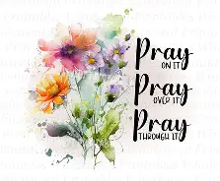
The Legacy At North Augusta: Joyce Tipton

Home: Mary Ultee, Mary Ann Maupin, Warner Sandquist, Polly Bare, Linda Quillen, Olive Prettyman, Nancy Hypes, Ruth & Lewis Kelley.

Friends and Family: Carolyn Hedrick-Williams (Colleen Cash), Damon Prettyman (Olive Prettyman).

Military: Carson Craig, Michael Little

This morning brings us our annual visit from the Heifetz International Music Institute in Staunton. FPC has been fortunate over these past few years to work with the Institute, which brings talented high school and college musicians from across the globe to the Valley for the summer to hone their skills. Today, we welcome the Housatonic Quartet, with violinists Jennie Lin (19) of Kaohsiung, Tiawan and Katie Liu (18) of Portland, Oregon; violist Bailin Jian (18) of Beijing, China and cellist Ian Jang (19) of Geneva, Switzerland. We are so grateful to these young musicians for sharing their talents with us this morning at FPC!

New Members Classes

We will continue to have New Members Class on the following Sundays: July 5 and July 19. We meet in the Barksdale Room at 9:30 a.m.
Those who would like to join the church are invited to do so during worship on Sunday, August 16.

An offering plate is available in the narthex.

FIRST PRESBYTERIAN CHURCH
WAYNESBORO, VIRGINIA

A community-minded congregation living out the love of Christ as we serve one
another with humility, gentleness, and patience through God’s grace.

June 28, 2026 11:00 AM

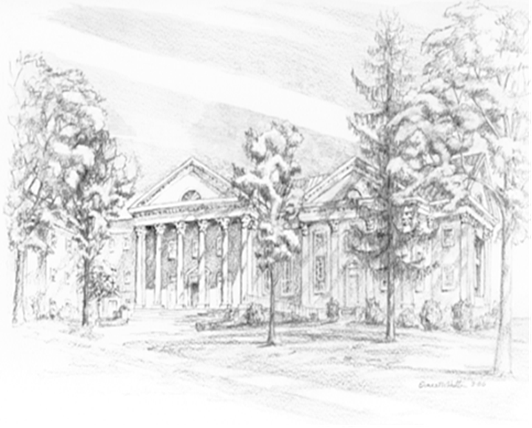

P.O. Box 877
249 South Wayne Avenue
Waynesboro, Virginia
(540) 949-8366
Church Website: www.firstpresway.org
Preschool Website: www.firstprespre.org
Email: church@firstpresway.com

