August 2, 2026 Liturgist: Joe Earhart

PRELUDE Hear My Prayer Mendelssohn (1809-1847)

WELCOME & ANNOUNCEMENTS

INTROIT O Lord, Hear My Prayer Berthier (1923-1994)

CALL TO WORSHIP
Leader: The Lord is gracious and merciful, slow to anger and abounding in steadfast love.
All: The Lord is good to all, and God’s compassion is over all that God has made.
Leader: The Lord upholds all who are falling and raises up all who are bowed down.
All: The eyes of all look to you, God, and you give them their food in due season.
Leader: You open your hand, satisfying the desire of every living thing.
All: The Lord is just in all God’s ways, and kind in all God’s doings. The Lord is near to all who call on the Lord, to all who call on the Lord in truth.

MORNING PRAYER

*OPENING HYMN #187 Savior, Like a Shepherd Lead Us BRADBURY

CHILDREN’S SERMON

CALL TO CONFESSION

PRAYER OF CONFESSION
Holy God, you have revealed yourself to us in Jesus Christ. Everything we need to know about you has been shown. Your goodness, mercy, healing and renewal are on full display. But sometimes we do not see what is right before us. Sometimes we miss the miracle. We misunderstand you, and so we misunderstand the world. Forgive us, we pray. Restore to us the ability to see you as you reveal yourself. Renew within us the capacity to perceive your way in the world, for this life, and in the life that is to come. We pray it in Jesus’ name, and for his sake.

SILENT PRAYER

ASSURANCE OF PARDON

*GLORIA PATRI #581 Glory Be to the Father GLORIA PATRI

OLD TESTAMENT READING Psalm 17:1-7 p.431

ANTHEM Just a Closer Walk Spiritual, arr. Fitzgibbon
Patrick Fitzgibbon, guitar, voice

SECOND READING Mark 4:1-9 p. 815

SERMON The Good Soil Rev. Samantha Coggins

*AFFIRMATION OF FAITH (from A Declaration of Faith, 1977)
Jesus Christ stands at the center of the biblical record.
The Bible is the account of God’s word and action in history, together with the response of God’s people in faith. It tells how the Lord has moved with Israel and the church
towards the kingdom of God, God’s just and loving rule over all.
It is the story of the one God, who is the Father, the Son, and the Holy Spirit.
That story is still unfolding and in faith we make it our own. It forms our memory and our hope. It tells us who we are and what we are to do. To retell it is to declare what we believe.

THE LORD’S SUPPER
Invitation
Great Thanksgiving
Communion of the People

*CLOSING HYMN #182 I Heard the Voice of Jesus Say KINGSFOLD

*BENEDICTION

POSTLUDE KINGSFOLD Reprise

This week’s liturgy is written by Baron Mullis and the Presbyterian Outlook.

LINK https://www.youtube.com/watch?v=o7Wz0YBr7OE

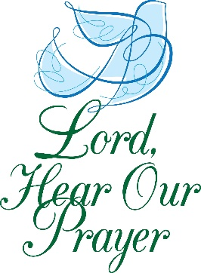

Summit Square : Ruth Quillen

Home: Mary Ultee, Mary Ann Maupin, Warner Sandquist, Polly Bare, Olive Prettyman, Nancy Hypes, Mike and Cathy Cunningham, Linda Quillen.

Friends and Family: Carolyn Hedrick-Williams (Colleen Cash), Damon Prettyman (Olive Prettyman), Jessica Faulk, Maria Costello (Cunningham).

Military: Carson Craig, Michael Little


Our Christian sympathies to the family of Joyce Tipton who passed on Saturday July 18.

Summer Book Study
We meet again this Wednesday, August 5, at 10:00 a.m. in the Barksdale Room, to discuss the ’Summer’ section of Good Soil by Jeff Chu.

FOOD BANK
Almost that time again! The Food Bank is looking for donations of:

Pencils
Pens
Glue sticks
Scissors
Crayons
Erasers
Spiral notebooks

FIRST PRESBYTERIAN CHURCH
WAYNESBORO, VIRGINIA

A community-minded congregation living out the love of Christ as we serve one another with humility, gentleness, and patience through God’s grace.

August 2, 2026 11:00 AM

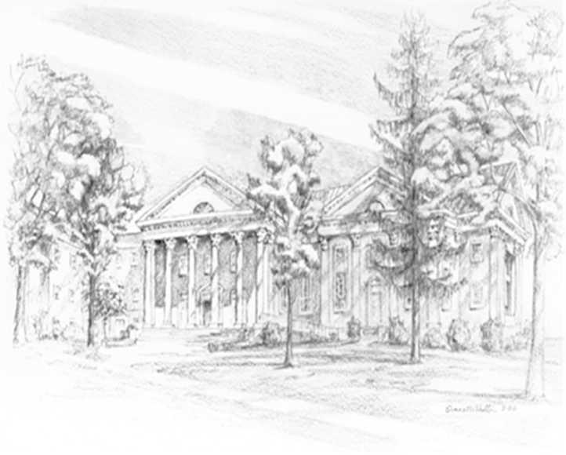

P.O. Box 877
249 South Wayne Avenue
Waynesboro, Virginia
(540) 949-8366
Church Website: www.firstpresway.org
Preschool Website: www.firstprespre.org
Email: church@firstpresway.com

