

THE COLUMNS
First Presbyterian Church, Waynesboro, VA
August 2026, Volume 64, Issue 8

First Presbyterian Church of Waynesboro is a community-minded
congregation living out the love of Christ as we serve one another with
humility, gentleness, and patience through God’s grace.

15 Toward evening the disciples approached him. “We’re out in the country and it’s getting
late. Dismiss the people so they can go to the villages and get some supper.”
16 But Jesus said, “There is no need to dismiss them. You give them supper.”
17 “All we have are five loaves of bread and two fish,” they said.
18-21 Jesus said, “Bring them here.” Then he had the people sit on the grass. He took the
five loaves and two fish, lifted his face to heaven in prayer, blessed, broke, and gave the
bread to the disciples. The disciples then gave the food to the congregation. They all ate
their fill. They gathered twelve baskets of leftovers. About five thousand were fed.
Matthew 14:15-21

When in doubt, always quote scripture. This is not one of the rules I have painstakingly collected over the years,
but perhaps it should be. Last month, we began with insights into basketball; for May, we are diving back into
the New Testament for illumination.
We are conditioned, I think, to look at the miraculous as magical, the theological equivalent of alchemy. Just as
the medieval alchemist sought to turn lead into gold, and thus enrich themselves without labor, we look at
miracles at least in part, as labor-saving plot devices: healing without the effort of treatment; gifts that eliminate
the need for impossible choices; rescue that makes of us passive recipients of grace. But, in the words of yet
another of my rules, God is not a magician; what we call miracles are signs of God at work in our midst - and
God hates to work alone.

In the feeding of the multitude, the disciples recognize a need - the crowd is getting hungry and the day is
mostly gone. This is a real problem, they know, but the best they can come up with is to send the crowds
back to town, where they might find some supper. But Jesus has something else in mind; not just pushing
the problem down the road, but actually doing something about the hunger of the people. He asks what
food is available, and is told, 5 rolls and 2 cooked fish - the lunch of a well-prepared young man. Jesus
then does the miraculous, but the miracle isn&#39;t magic- Jesus does not make everyone feel full, or have
manna fall from the heavens. The miracle happens through the work of the disciples. It is the disciples
who organize the people, getting them to sit down in an orderly fashion; they who oversee the distribution
of the loaves and fishes, making sure everyone is fed; even making sure the leftovers are collected. And
that, friends, leads us to Rule #10:




AUGUST MUSIC NOTES

August is a month of transition, from summer vacations to the beginning of the school year and autumn schedules beginning to demand our attention. In these waning days of summer relaxation, we here at First Presbyterian Church will have the opportunity to experience the musical talents of members of our congregation.

For the first Sunday of the month, Patrick Fitzgibbon will sing and play guitar. Since he began attending FPC, Patrick has sung bass in the choir. The University of Chicago alum will play his own arrangement of the spiritual Just a Closer Walk for the anthem.

Also on 2 August, we celebrate the life of Joyce Tipton. The front pews will not be the same without her consistent presence and support of the mission of FPC. At her 12:30 memorial service, Joe Earhart and Terry Crickenberger will sing Swing Low, Sweet Chariot. The Queen City Porch Swingers – Greg Moody, clarinet, Remy Duguet, bass and Bob Russell, banjo - will render the recessional, Oh, When the Saints Go Marching In. Roger will play organ throughout the service, which will include some of Joyce’s favorite hymns.

On 9 August, soprano Jean Hashagen will sing an arrangement of Make Me a Channel of Your Peace. The Stalwart member of our choir will also sing What Does the Lord Require for the Introit that day.

We welcome new members to our congregation on 16 August. To celebrate that august event, the choir will return from their summer hiatus to sing the anthem Draw Us in the Spirit’s Tether. The text is ideal for the day that folks join the FPC flock: “For when humbly in Thy name, two or three are met together, Thou art in the midst of them!”

The men of the choir will sing the anthems on the final two Sundays of August. Max Daggy will sing a solo on 23 August, and the men’s quartet - Terry Crickenberger, Joe Earhart, Patrick Fitzgibbon and Roger - will sing the anthem on the final Sunday of the month.

Special thanks to Mike Cunningham for stepping forward to fabricate a roll-around dolly for the harpsichord. His generosity of skill, time and effort will help preserve the instrument as it is so frequently moved.

FPC is blessed to have members committed to the mission of the church: worshipping God, educating young children, feeding the hungry and fulfilling the soul through music. We are so grateful to be part of the community and look forward to continuing the musical ministry in the church.

Blessings,

Roger and Kimberlea Daggy

SESSION HIGHLIGHTS

Session held a Stated Meeting on July 21, 2026.
The church experienced water damage from a broken water line in the upstairs kitchen, which resulted in repairs needed to several areas below, including one preschool classroom. Structural repairs are necessary and are being addressed, including replacement of the floor and testing for asbestos before occupancy. The classroom will be available as soon as possible.
Preschool starts August 3 with some new teachers and aides on site.
A Mobile Presbytery will be at FPC on Wednesday, August 26, from 10-1.
Mission/Outreach: Separate article elsewhere in the newsletter.
A Memorial Service for Joyce Tipton will be held at 12:30 p.m. on Sunday, August 2.
Rev. Coggins will preach August 17 at 7:00 p.m. at one of the Revival Services at Union Baptist Church in Waynesboro. All are welcome to attend.
Motion: A Congregational Meeting has been called at the conclusion of worship on Sunday, August 16, to elect new officers. New members will be welcomed at the service.
All Session meetings are opened and closed with prayer. Joys and concerns are shared. The next scheduled Stated Meeting is Tuesday, August 11.
--Betsy Ruehl, Clerk of Session

COLLECTING PERSONAL SCHOOL SUPPLIES FOR FOOD BANK IN AUGUST
Spiral notebooks, pencils, pens, scissors, erasers, crayons, glue sticks





IN MEMORIAM
Joyce Lee Miller Tipton
December 24, 1931 – July 18, 2026
Member of First Presbyterian Church 70+ Years

Summit Square : Ruth Quillen

Home: Mary Ultee, Mary Ann Maupin, Warner Sandquist, Polly Bare, Olive Prettyman, Nancy Hypes, Mike and Cathy Cunningham, Linda Quillen.

Friends and Family: Carolyn Hedrick-Williams (Colleen Cash), Damon Prettyman (Olive Prettyman), Jessica Faulk, Maria Costello (Cunningham).

Military: Carson Craig, Michael Little
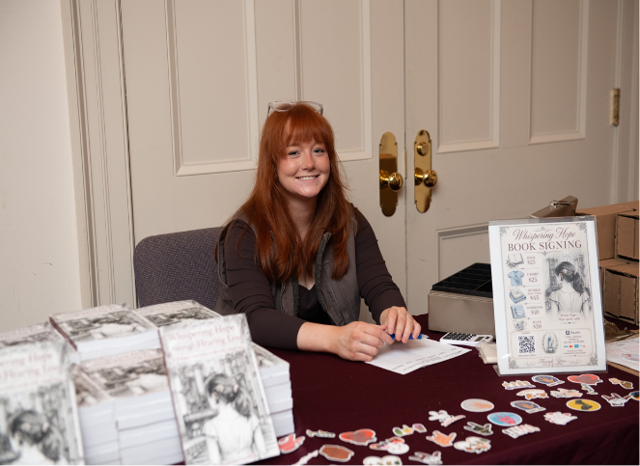

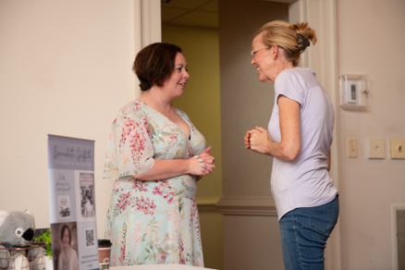
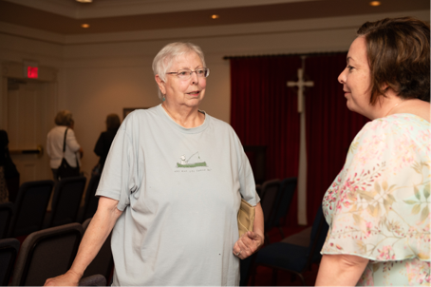



We are sad to see our summer camp come to an end - so many memories as well as new friends with new experiences. Summer camp was a huge success once again. We ended with our “Summer Bash” having ice cream and a big water slide for everyone to enjoy, even the teachers!
We will be having our Back-to-School Night, July 30th, from 6:00pm-7:00pm for all families to meet their teachers as well as see their classrooms. Preschool will resume on August 3rd; we are so excited to begin our new school year to see our returning friends and welcome our new ones.
The preschool has been working hard on a few new events for the year. One of our biggest events will be a Car Show fundraiser! So far everyone from the community has pitched in and joined our school to make this happen. This Show will be September 26th 10am-2pm







SOME INTERESTING TID-BITS FROM GENERAL ASSEMBLY

In 1972, Ruling Elder Lois Stair (1923-1981) took the stage as the newest moderator of the PCUSA General Assembly. Location just happened to be Milwaukee, the same city where the 2026 meeting is taking place. This was a historic moment as she was the first woman elected to the position – one of the highest leadership positions within the church. She had been serving as a ruling elder at First Presbyterian Church of Waukesha, Wisconsin, since 1957.
At her first address she announced, “Here I am, filled with amazement and gratitude and standing in the need of prayer.”
She went on to mention other trailblazing women who’d paved the way.
In 1922 the Presbyterian General Assembly allowed women to be deaconesses – a larger role than before but limited as a deaconess could not preach and an elder could. Sarah E. Dickenson had been ordained as a deaconess and was serving as a Director of Religious Education in Wauwatosa, Wisconsin.
Overture B passed the General Assembly on May 30, 1931, “which would make women eligible for ordination as elders”. Sarah, who had considerable experience and was aptly trained, was ordained two weeks later and the PC(USA) had its first woman ruling elder.
In October 1956, almost three decades after Dickenson’s milestone ordination, another historic ceremony took place - Margaret Towner’s ordination as the first woman minister of the Presbyterian Church. She had attended Union Theologica Seminary from 1951-1954 and worked as a commissioned church worker (CCW), one of the positions in the church open to women at the time. It was not easy sailing, however. Installed as an assistant pastor, a year passed and she had yet to preach at a regular service. Her colleagues often vocalized their expectation that she’d be around only until she got married and she faced issues of pay inequity in various situations.
In 2026 Rev. Margaret Towner is 101 years old.
- Betsy Ruehl, Editor

FPC BOOK STUDY CONTINUES


“Good Soil: The Education of an Accidental Farmhand” by Jeff Chu
(A true story of a working farm at Princeton Seminary)
Wednesdays at 10:00 in the Barksdale Room
Led by Rev. Samantha Coggins
July 8 – September 2
A limited number of books is available in the Church Office
Meetings open to non-members of First Presbyterian Church as well



BETTER TOGETHER BIBLE STUDIES
Study resumes on September 14




BIRTHDAYS ANNIVERSARIES
10-Bob Miller 4- Lewis & Ruth Kelley
13- Craig Cavenaugh 17 Richard & Jeannie Curry
16 Nancy Hypes 31 Ron & Carrol Smith



CHURCH OFFICERS:
Treasurer – Colleen Cash
Members of Session - Jean Hashagen, Betsy Ruehl
Cynthia Hoover, Bob Miller and Nancy Hypes.


Sunday, August 2
11 am Worship
12:30 pm Memorial Joyce Tipton
Monday, August 3
Preschool Starts
Wednesday, August 5
10 am Book Study - Barksdale Room
Thursday, August 6
6-7:30 pm Food Bank
Sunday, August 9
11 am Worship
Tuesday, August 11
2:30 pm Session-Barksdale Room
Wednesday, August 11
10 am Book Study - Barksdale Room
Thursday, August 13
2-4 pm Food Bank
Sunday, August 16
11 am Worship New Members and Elders
Wednesday, August 19
10 am Book Study - Barksdale Room
Thursday, August 20
6-7:30 pm Food Bank
Sunday, August 23
11 am Worship
Wednesday, August 26
10 am Book Study-Barksdale Room
Thursday, August 27
2-4 pm Food Bank

