August 23, 2026 Liturgist: Patrick Fitzgibbon

PRELUDE Andante in D Mendelssohn (1809-1847)

WELCOME & ANNOUNCEMENTS

INTROIT Let All the World Routley (1917-1982)

CALL TO WORSHIP
Leader: Hear O Israel! I am calling! Are you listening?
All: We are here and we are ready.
Leader: Beloved Children, who do you say that I am?
All: You are our rock and our redeemer. Our trust is in you. Our hearts,
minds and souls belong to you!
Leader: I created you, named you and have a calling for your life.
All: We give thanks with our whole hearts for your steadfast love!

MORNING PRAYER

*OPENING HYMN #330 Our Help Is in the Name of God OLD 124TH

CHILDREN’S SERMON

CALL TO CONFESSION

PRAYER OF CONFESSION
God of truth, like a moth that gnaws at wool, our brokenness eats away at our souls. We allow the cacophony of greed, selfishness, apathy and ignorance to drown out your voice as you call us to see the suffering in our world and respond to the needs of your children. In our busy lives, we convince ourselves that there is no time to help, no space for prayer and no need for justice. Forgive us. Remind us that only when we slow down and breathe deeply of your Holy Spirit and holy Word can our ears hear your voice. Inspire us to greater love for you and for one another. Amen.

SILENT PRAYER

ASSURANCE OF PARDON

*GLORIA PATRI #581 Glory Be to the Father GLORIA PATRI

FIRST SCRIPTURE READING Psalm 124 p.498

ANTHEM Elijah: Lord God of Abraham Mendelssohn
Maximilian Daggy, baritone

Lord God of Abraham, Isaac and Israel:
This day let it be known that Thou art God,
And I am Thy servant!
O show to all this people that I have done these things
According to Thy word!
O hear me, Lord, and answer me,
And let their hearts again be turned.

SECOND SCRIPTURE READING Deuteronomy 6:4-9 p. 143

SERMON Hear, O Israel Rev. Samantha L. Coggins

*AFFIRMATION OF FAITH The Apostles’ Creed (hymnal pg. 35)

PRAYERS of the PEOPLE and THE LORD’S PRAYER

*CLOSING HYMN #63 The Lord is God AZMON

*BENEDICTION

POSTLUDE Sonata in B-flat, op. 65 no 4: I Mendelssohn

This week’s liturgy is provided by Rev. Jeny Carlson and the Presbyterian Outlook.

Link: https://www.youtube.com/watch?v=qW9C70KZkaE



Home: Mary Ultee, Mary Ann Maupin, Warner Sandquist, Polly Bare, Linda Quillen, Olive Prettyman, Nancy Hypes, Ruth & Lewis Kelley.

Friends and Family: Carolyn Hedrick-Williams (Colleen Cash), Damon Prettyman (Olive Prettyman).

Military: Carson Craig, Michael Little

Book Study This Wednesday
Our second-to-last meeting about Jeff Chu’s Good Soil is this Wednesday, August 26, at 10:00 a.m. Note that we will meet in the Parlor, rather than the Barksdale Room, as presbytery staff will be using that room (see next announcement).

Shenandoah Presbytery ‘Mobile' Office
Due to renovations to their office space, Shenandoah Presbytery staff will be operating out of the Barksdale Room at church this Wednesday, August 26, from 10:00 a.m. to 1:00 pm. Congregants from throughout the presbytery, including those of us here at FPC, are encouraged to stop in and say hello!

CROP Walk is Sunday, September 20
We will participate again this year in the CROP walk to end hunger, on Sunday, September 20. Join our church’s team by going to East Augusta Waynesboro CROP walk online. For more details, see the display table in the Narthex on your way out.

An offering plate is available in the narthex.

FIRST PRESBYTERIAN CHURCH
WAYNESBORO, VIRGINIA

A community-minded congregation living out the love of Christ as we serve one
another with humility, gentleness, and patience through God’s grace.

August 23, 2026 11:00 AM

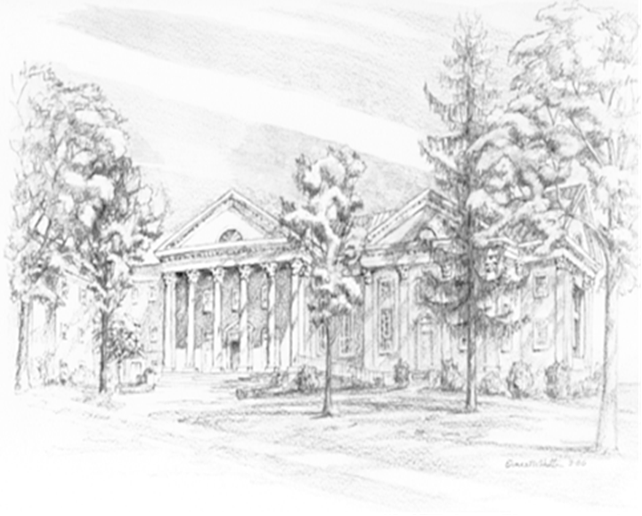

P.O. Box 877
249 South Wayne Avenue
Waynesboro, Virginia
(540) 949-8366
Church Website: www.firstpresway.org
Preschool Website: www.firstprespre.org
Email: church@firstpresway.com

