August 9, 2026 Liturgist: Cynthia Hoover

PRELUDE Préambule, Op. 31, no. 1 Vierne (1870-1936)

WELCOME & ANNOUNCEMENTS

INTROIT What Does the Lord Require of You? Strathdee (b. 1941)
text can be found in Hymn #70

CALL TO WORSHIP
Leader: Let me hear what the Lord God says, because he speaks peace to his people and to his faithful ones.
All: Faithful love and truth have met; righteousness and peace have kissed.
Leader: Truth springs up from the ground; righteousness gazes down from heaven.
All: Yes, the Lord gives what is good, and our land yields its produce.
Leader: Righteousness walks before God, making a road for his steps.

MORNING PRAYER

*OPENING HYMN #299 You Servants of God, Your Master Proclaim HANOVER

BLESSING OF THE BACKPACKS

CALL TO CONFESSION

PRAYER OF CONFESSION
Gracious God, forgive us that we ever doubted your grace; that we thought anything could separate us from you; that we heaped shame upon shame, and fear upon fear.
Teach us to treat crisis with gentleness, shame with hope, fear with love, and danger with courage. Give us the strength to live life, share life, and save life.
We pray in the name of the Resurrected Christ. Amen.

SILENT PRAYER

ASSURANCE OF PARDON

*GLORIA PATRI #581 Glory Be to the Father GLORIA PATRI

FIRST SCRIPTURE READING Psalm 85:8-13 p.473

ANTHEM Make Me a Channel of Your Peace arr. Hayes (b. 1953)
(text can be found in hymn 753)
Jean Hashagen, soprano

GOSPEL READING Micah 6:6-8 p. 757

SERMON Do Justice, Love Faithfully, Walk Humbly Rev. Samantha L. Coggins

*AFFIRMATION OF FAITH
We trust in God the Holy Spirit, everywhere the giver and renewer of life.
The Spirit justifies us by grace through faith, sets us free to accept ourselves
and to love God and neighbor, and binds us together with all believers
in the one body of Christ, the Church. The same Spirit who inspired the prophets and apostles
rules our faith and life in Christ through Scripture, engages us through the Word proclaimed,
claims us in the waters of baptism, feeds us with the bread of life and the cup of salvation,
and calls women and men to all ministries of the Church.
In a broken and fearful world the Spirit gives us courage to pray without ceasing,
to witness among all peoples to Christ as Lord and Savior, to unmask idolatries in Church and culture, to hear the voices of peoples long silenced, and to work with others for justice, freedom, and peace.

PRAYERS of the PEOPLE and THE LORD’S PRAYER

*CLOSING HYMN #739 O For a Closer Walk with God CAITHNESS

*BENEDICTION

POSTLUDE Fugue in C, BuxWV 174 Buxtehude (1637-1707)

Link: https://www.youtube.com/watch?v=Mu-jCdp_VF8

This week’s liturgy is provided by Teri McDowell Ott and the Presbyterian Outlook. The prayers of Confession and of the People are by Rev. Carol Holbrook Prickett.

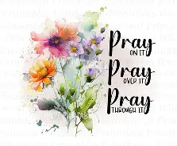
Summit Square: Ruth Quillen

Home: Mary Ultee, Mary Ann Maupin, Warner Sandquist, Polly Bare, Linda Quillen, Olive Prettyman, Nancy Hypes, Ruth & Lewis Kelley.

Friends and Family: Carolyn Hedrick-Williams (Colleen Cash), Damon Prettyman (Olive Prettyman), Carol Perkins.

Military: Carson Craig, Michael Little

We continue to hold in prayer Jeannie Curry and Tootsie Vest, as they grieve the loss of their aunt, Betsy Boswell.

Will meet this Wednesday, August 12, at 10:00 am. We will be reviewing the last half of “Summer” (especially ‘Long Beans’, ‘goat’, and ‘Heron’). You are welcome to begin the ‘Autumn‘ section as well.

Invitation to Worship at Union Baptist Church, 8/17 at 7:00 pm
“Will You not revive us again, that Your people may rejoice in You?” (Ps. 85:6) First Presbyterian is invited to worship at Union Baptist Church, Waynesboro, on Monday, August 17 at 7:00 pm. Samantha was invited by Rev. Dr. Earl Pendleton, UBC’s pastor, to be one of three guest preachers that week, for the congregation's Revival days (see flyer in Narthex). A section of FPC's choir will be singing. The theme is “Revive Us Again: Renewed Hearts, Rejoicing People.”

FOOD BANK
Almost that time again, The Food Bank is looking for donations of:
Pencils
Pens
Glue sticks
Scissors
Crayons
Erasers
Spiral notebooks


An offering plate is available in the narthex.

FIRST PRESBYTERIAN CHURCH
WAYNESBORO, VIRGINIA

A community-minded congregation living out the love of Christ as we serve one
another with humility, gentleness, and patience through God’s grace.

August 9, 2026 11:00 AM

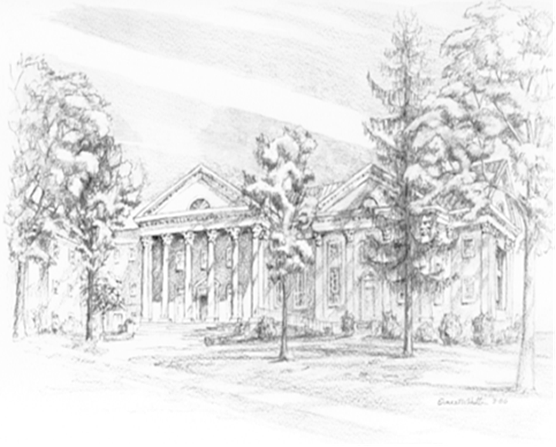

P.O. Box 877
249 South Wayne Avenue
Waynesboro, Virginia
(540) 949-8366
Church Website: www.firstpresway.org
Preschool Website: www.firstprespre.org
Email: church@firstpresway.com

