

THE COLUMNS
First Presbyterian Church, Waynesboro, VA
July 2026, Volume 64, Issue 7

First Presbyterian Church of Waynesboro is a community-minded
congregation living out the love of Christ as we serve one another with
humility, gentleness, and patience through God’s grace.

15 Toward evening the disciples approached him. “We’re out in the country and it’s getting
late. Dismiss the people so they can go to the villages and get some supper.”
16 But Jesus said, “There is no need to dismiss them. You give them supper.”
17 “All we have are five loaves of bread and two fish,” they said.
18-21 Jesus said, “Bring them here.” Then he had the people sit on the grass. He took the
five loaves and two fish, lifted his face to heaven in prayer, blessed, broke, and gave the
bread to the disciples. The disciples then gave the food to the congregation. They all ate
their fill. They gathered twelve baskets of leftovers. About five thousand were fed.
Matthew 14:15-21

When in doubt, always quote scripture. This is not one of the rules I have painstakingly collected over the years,
but perhaps it should be. Last month, we began with insights into basketball; for May, we are diving back into
the New Testament for illumination.
We are conditioned, I think, to look at the miraculous as magical, the theological equivalent of alchemy. Just as
the medieval alchemist sought to turn lead into gold, and thus enrich themselves without labor, we look at
miracles at least in part, as labor-saving plot devices: healing without the effort of treatment; gifts that eliminate
the need for impossible choices; rescue that makes of us passive recipients of grace. But, in the words of yet
another of my rules, God is not a magician; what we call miracles are signs of God at work in our midst - and
God hates to work alone.

In the feeding of the multitude, the disciples recognize a need - the crowd is getting hungry and the day is
mostly gone. This is a real problem, they know, but the best they can come up with is to send the crowds
back to town, where they might find some supper. But Jesus has something else in mind; not just pushing
the problem down the road, but actually doing something about the hunger of the people. He asks what
food is available, and is told, 5 rolls and 2 cooked fish - the lunch of a well-prepared young man. Jesus
then does the miraculous, but the miracle isn&#39;t magic- Jesus does not make everyone feel full, or have
manna fall from the heavens. The miracle happens through the work of the disciples. It is the disciples
who organize the people, getting them to sit down in an orderly fashion; they who oversee the distribution
of the loaves and fishes, making sure everyone is fed; even making sure the leftovers are collected. And
that, friends, leads us to Rule #10:

Dear members and friends of First Presbyterian Church,

At the time I am writing to you here, I sit at the Charlottesville airport, en route to Milwaukee, WI, to represent our Presbytery (Shenandoah Presbytery) at the 227th General Assembly (‘GA’). GA is the annual meeting of our denomination, the PCUSA, which gathers elders, ministers, and youth in one place to make decisions about our policies and governance. I began my work with my assigned committee last week, online. The 65 other folks I met with (on Zoom!), from PCUSA presbyteries across the country including Puerto Rico, have enlivened me for all of the in-person work we will do in Milwaukee. Stay tuned for my full report on GA, in the August edition of the Columns.

In the meantime, the month of July brings two fellowship opportunities for current and prospective members of our church:

New Members Classes
Sunday, July 5 @ 9:30 a.m., Barksdale Room
Sunday, July 19 @ 9:30 a.m., Barksdale Room
*On Sunday, August 16, during 11:00 a.m. worship in the sanctuary, we will recognize those from the New Members class who desire to join the church, officially blessing and welcoming them as a congregation!

Summer Book Study - Good Soil by Jeff Chu
Wednesdays @ 10:00 a.m., Barksdale Room, in July and August, beginning July 8.

Please pray for those who are participating in the opportunities above, especially those who are discerning membership at First Presbyterian. In July, how can we continue to be the faithful body of Christ to all in our midst?

Grace & peace,
Samantha
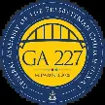


JULY MUSIC NOTES

Happy birthday, America! On the first Sunday of July, we will celebrate our country’s 250th with patriotic music throughout the service. The hymns will be My Country ‘Tis of Thee and O Beautiful for Spacious Skies. We will also have two renditions of our National Anthem, opening and closing the service. The prelude arrangement will be played by Sarah Braverman, who teaches piano in Fishersville. Her students play studio recitals at FPC twice a year, and she is playing on 5 July to thank FPC for allowing her to use the Sanctuary for those recitals. Ms. Braverman will also provide the special music, an arrangement of the hymn Be Not Afraid. The postlude will be the standard version of the National Anthem which our 1893 Woodberry and Harris pipe organ renders with uncommon grandeur!

On the second Sunday of July, tenor Terry Crickenberger will sing The Call for the anthem. It is one of the Five Mystical Songs by Ralph Vaughan Williams (1872-1958), with text by Welsh poet and Anglican priest, George Herbert (1593-1633). We are grateful to Terry for singing a solo on 12 July!

Roger and Kimberlea will be away on 19 July. As many of you know, the Daggys were married at FPC in 1988 and feel extremely fortunate to make music in the place where their union was blessed! The wonderfully kind and capable Diane Kingsbury will be at the helm of our historic organ that day.

For the final Sunday of July, we welcome Jacob Wilder to our Sanctuary. Jacob is principal horn of the Virginia Symphony, and during the summer, he plays principal horn with the Wintergreen Festival Orchestra. We are grateful to him for sharing his gifts with us on 25 July. Jacob and Roger will play works by Reinhold Glière (1875-1956) for the prelude and special music.

We truly appreciate the ongoing support of the music program here at FPC.

Blessings –

Roger and Kimberlea Daggy

NO FIRST FRIDAY ORGAN CONCERTS THIS SUMMER

Join us again on
October 4

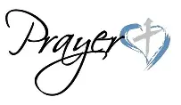

HIGHLIGHTS of the
HIGHLIGHTS OF THE MEETING OF SHENANDOAH PRESBYTERY
ON MAY 19, 2026, AT CHARLES TOWN PRESBYTERIAN CHURCH

99 participants gathered for the meeting. No one from FPC was able to attend.
Rev. Maryann McKibbin Dana, Associate Pastor at Trinity PC in Herndon, VA, was the preacher of the
day. The educational hour was entitled “Designing Your Ministry”.
The Commissioned Elder for the Goshen Congregation shared the session’s resolution on peacemaking,
asking each session in our presbytery to consider doing the same.
The Commissioners to General Assembly were commissioned: Rulings Elders Mark Facknitz (Trinity)
and Joe Crockett (Bridgewater) and Teaching Elders Bob Vaughn (Romney) and Samantha Coggins (1st
Waynesboro).
The General Presbyter and Stated Clerk, the Rev. Bronwen Boswell, announced that she is retiring
September 30, 2026. She will be moving to Buffalo, NY, to be near family.
All Presbytery meetings are opened and closed with prayer. The next Presbytery meeting will be held at
9:30 a.m. on August 22 via zoom.

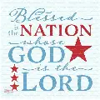

THE UNITED STATES OF AMERICA
CELEBRATES 250 YEARS OF INDEPENDENCE
July 4, 1776 – July 4, 2026

Independence Day, known colloquially as the Fourth of July, is a federal holiday in the United States which commemorates the adoption of the Declaration of Independence on July 4, 1776, establishing the United States of America.
By doing this, the delegates to the Second Continental Congress declared that the Thirteen Colonies were no longer subject (and subordinate) to the monarch of Britain, King George III, and were now united, free, and independent states. The Congress voted to approve independence by passing the Lee Resolution on July 2 and adopted the Declaration of Independence two days later, on July 4.
Thomas Jefferson was asked to author the first draft of the Declaration. While Jefferson consulted extensively with the other four members of the Committee of Five, he largely wrote the Declaration of Independence in isolation over 17 days between June 11 and June 28, 1776, from the second floor he was renting in a private home at 700 Market Street in Philadelphia, now known as the Declaration House, and withing walking distance of Independence Hall.
By remarkable coincidence, Thomas Jefferson and John Adams, the only two signatories of the Declaration of Independence later to serve as presidents of the United States, both died on the same day: July 4, 1826, which was the 50th anniversary of the Declaration. James Monroe, another Founding Father who was elected president, died on July 4, 1831, making him the third President who died on the anniversary of Independence. Former President Calvin Coolidge was born on July 4, 1872.



It is so hard to believe that we have already finished up our first month of summer camp and are heading into our final month. We have had so much fun learning about different things as well as meeting new friends. We have learned about the different animals that live in zoos. Mrs. Lynda’s class went on their safari hunt around the preschool. Our school age children had a blast on a nature hunt learning about different insects that can be found while exploring the outside. Ms. Amber’s class got to experience how to “milk a cow and sheer a sheep” during farm week in the classroom, as well as learning about all the other animals that lived on the farm. Our school age groups have enjoyed walking to the Wayne theater to see a movie as well as walking to the Waynesboro Library to explore and look for books on the shelves and check them out themselves.

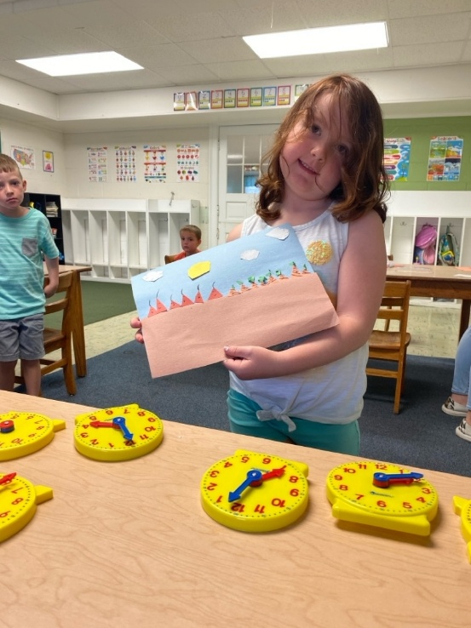
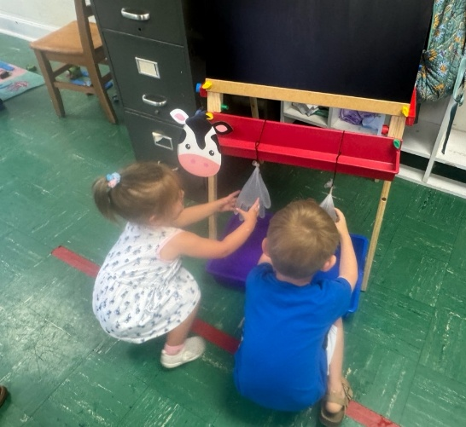

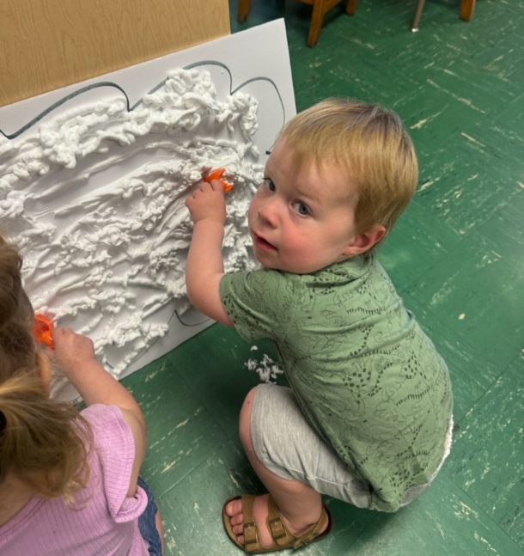

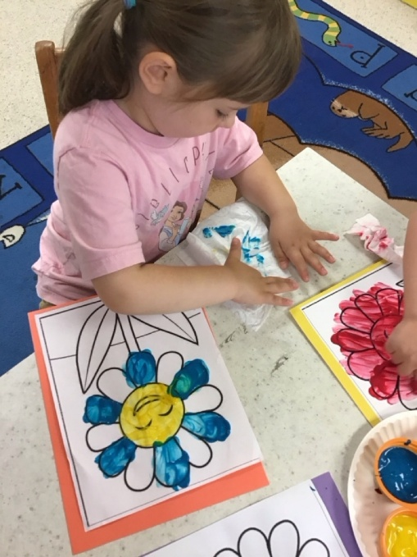

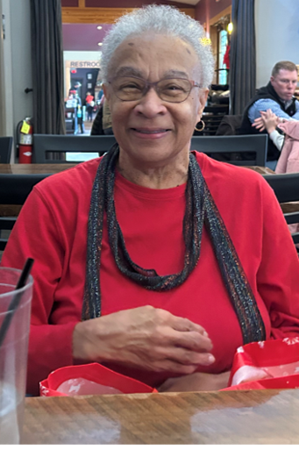

Mrs. Carol Perkins resigned from our Preschool the end of May. Carol has been with the Preschool first as an aide, and for the last several years a teacher for the two-year-olds. Carol’s “children” adored her. She was dearly loved and will be missed.

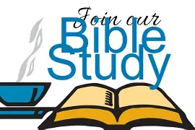

BETTER TOGETHER BIBLE STUDIES
Study resumes on September 14

FPC BOOK STUDY BEGINS WEDNSDAY, JULY 8

“Good Soil: The Education of an Accidental Farmhand” by Jeff Chu
(A true story of a working farm at Princeton Seminary)
“This book is a tribute to friendship, to the sacredness of our bond with the
natural world, and to how love can grow from the unlikeliest of places”
Wednesdays at 10:00 in the Barksdale Room
Led by Rev. Samantha Coggins
July 8 – September 2 (except July 29)
A limited number of books is available in the Church Office
Before the first meeting, please read through the section “dog”, p.52
Meetings open to non-members of First Presbyterian Church as well

LITURGISTS BIRTHDAYS ANNIVERSARIES
4- Mike Cunningham 7- Don & Jeannie Hashagen
9- Mary Ultee 7- Randy & Nancy Hypes
18 - Earlene Templeman 17- Roger & Kimberlea Daggy
21- Ruth Quillen

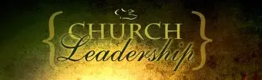

CHURCH OFFICERS:
Treasurer – Colleen Cash
Members of Session - Jean Hashagen, Betsy Ruehl
Cynthia Hoover, Bob Miller and Nancy Hypes.



Thursday July 2
6-7:30 pm Food Bank
Sunday, July 5
11 am Worship -Sarah Braverman
Wednesday, July 8
10 am Book Study - Barksdale Room
Thursday, July 9
2-4 pm Food Bank
Sunday, July 12
11 am Worship
Tuesday, July14
2:30 pm Session-Barksdale Room
Wednesday, July 15
10 am Book Study - Barksdale Room
Thursday, July 16
6-7:30 Food Bank
Sunday, July 19 Diane Kingsbury
11 am Worship
Wednesday, July 22
10 am Book Study - Barksdale Room
Thursday, July 23
2-4 pm Food Bank
Sunday, July 26
11 am Worship
Wednesday, July 29 No Book Study

“Just for Fun” Days

July 11: International Town Criers Day
July 15: National Hot Dog Day
July 22: Spooner’s Day
July 23: National Day of the Cowboy
July 27: Take Your Houseplants for a Walk Day
July 30: National Cheesecake Day

