August 30, 2026 Liturgist: Jean Hashagen

PRELUDE Come, Holy Spirit, BuxWV 199 Buxtehude (1637-1707)

WELCOME & ANNOUNCEMENTS

INTROIT Come Into God’s Presence, singing Alleluia Anonymous

CALL TO WORSHIP
Leader: Praise the Lord.
All: The Lord’s name be praised.
Leader: Great God, you have been generous and marvelously kind.
All: Give us such wonder, love, and gratitude that we may sing praises to you, and joyfully honor your name, through Jesus Christ our Lord.

MORNING PRAYER

*OPENING HYMN #620 Praise My Soul the King of Heaven LAUDA ANIMA

CHILDREN’S SERMON

CALL TO CONFESSION

PRAYER OF CONFESSION
Merciful God, we confess that we have sinned against you in thought, word and deed, by what we have done, and by what we have left undone. We have not loved you with our whole heart and soul and strength. We have not loved our neighbors as ourselves. In your mercy forgive what we have been, help us amend what we are, and direct what we shall be, so that we may delight in your will and walk in your ways, to the glory of your holy name.
Through Christ, our Lord. Amen.

SILENT PRAYER

ASSURANCE OF PARDON

*GLORIA PATRI #581 Glory Be to the Father GLORIA PATRI

FIRST SCRIPTURE READING Psalm 16 p.430

ANTHEM In the Garden Miles (1868-1946)
Terry Crickenberger, Joe Earhart, Patrick Fitzgibbon and Roger Daggy

1. I come to the garden alone, while the dew is still on the roses;
And the voice I hear, falling on my ear, the Son of God discloses.
Refrain: And He walks with me, and He talks with me, and He tells me I am His own, And the joy we share as we tarry there, none other has ever known.
2. He speaks, and the sound of His voice is so sweet the birds hush their singing;
And the melody that He gave to me within my heart is ringing. [Refrain]
3. I'd stay in the garden with Him tho' the night around me be falling;
But He bids me go; thro' the voice of woe, His voice to me is calling. [Refrain]

SECOND SCRIPTURE READING 1 Thessalonians 5:16-18 p.960

SERMON JOY Rev. Rachel Hamburger

*AFFIRMATION OF FAITH The Apostles’ Creed hymnal pg. 35

PRAYERS of the PEOPLE and THE LORD’S PRAYER

*CLOSING HYMN #804 Rejoice, Ye Pure in Heart! MARION

*BENEDICTION

POSTLUDE Toccata in F, BuxWV 157 Buxtehude

Link: https://www.youtube.com/watch?v=xGe9N094ocs

Better Together Pulpit Swap Today
Today we welcome Rev. Rachel Hamburger, pastor at Smyrna Presbyterian Church, as our worship leader and preacher. We rejoice in this opportunity for fellowship among the Better Together congregations (Smyrna, Finley, Westminster, Second, and First).





Home: Mary Ultee, Mary Ann Maupin, Warner Sandquist, Polly Bare, Linda Quillen, Olive Prettyman, Nancy Hypes, Ruth & Lewis Kelley.

Friends and Family: Carolyn Hedrick-Williams (Colleen Cash), Damon Prettyman (Olive Prettyman).

Military: Carson Craig, Michael Little

Last Book Study This Wednesday
Our final discussion of Jeff Chu’s Good Soil is this Wednesday, September 2, at 10:00 a.m. In preparation, please read through the end of the book.

CROP Walk is Sunday, September 20
We will participate again this year in the CROP walk to end hunger, on Sunday, September 20. Join our church’s team by going to East Augusta Waynesboro CROP walk online. For more details, see the display table in the Narthex on your way out.

An offering plate is available in the narthex.

FIRST PRESBYTERIAN CHURCH
WAYNESBORO, VIRGINIA

A community-minded congregation living out the love of Christ as we serve one
another with humility, gentleness, and patience through God’s grace.

August 30, 2026 11:00 AM

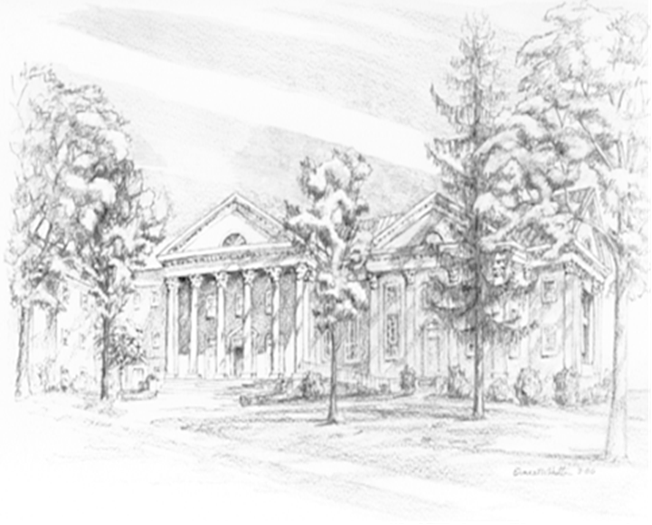

P.O. Box 877
249 South Wayne Avenue
Waynesboro, Virginia
(540) 949-8366
Church Website: www.firstpresway.org
Preschool Website: www.firstprespre.org
Email: church@firstpresway.com

