October 4, 2026 Liturgist: Betsy Ruehl

PRELUDE Prelude in F, BuxWV 145 Buxtehude (1637-1707)

WELCOME & ANNOUNCEMENTS

INTROIT Now Enter In Hebble (1934-2020)

CALL TO WORSHIP
Leader: We come to build a legacy
All: laying stone upon stone
Leader: placing our faithful deeds one upon another
All: until a whole new world is built.
Leader: We are only one layer, but we play our part.
All: Building upon Christ, our Cornerstone and our Strength!

MORNING PRAYER

*OPENING HYMN #223 When I Survey the Wondrous Cross HAMBURG

CHILDREN’S SERMON

CALL TO CONFESSION

PRAYER OF CONFESSION
Merciful Lord, upon whom we build our life, forgive us for our sins. We are prone to folly: boasting in our success, dreaming selfish dreams, taking credit and blame when neither is due us. Give us humble hearts, O Lord, admitting that all our good works depend on your grace in the end. Help us do our part, and give the rest to you. We pray in the name of Christ, our Rock and our Redeemer. Amen.

SILENT PRAYER

ASSURANCE OF PARDON

*GLORIA PATRI #581 Glory Be to the Father GLORIA PATRI

FIRST READING Philippians 3:7-11 p. 954

ANTHEM Eat This Bread Berthier (1923-1994)
(text can be found in hymn 527)

SECOND READING 1 Corinthians 3:1-15 p. 927

SERMON Building on Christ Rev. Samantha Coggins

AFFIRMATION OF FAITH
In life and in death we belong to God. Through the grace of our Lord Jesus Christ, the love of God, and the communion of the Holy Spirit, we trust in the one triune God, the Holy One of Israel, whom alone we worship and serve.
In gratitude to God, empowered by the Spirit, we strive to serve Christ in our daily tasks and to live holy and joyful lives, even as we watch for God’s new heaven and new earth, praying, “Come, Lord Jesus!”
With believers in every time and place, we rejoice that nothing in life or in death can separate us from the love of God in Christ Jesus our Lord.
Glory be to the Father, and to the Son, and to the Holy Spirit. Amen.

THE LORD’S SUPPER
Invitation
Great Thanksgiving
Communion of the People

*CLOSING HYMN # 463 How Firm a Foundation FOUNDATION

*BENEDICTION

POSTLUDE Fugue in F, BuxWV 145 Buxtehude

The Great Prayer of Thanksgiving (Communion) was written by Teri McDowell Ott and the Presbyterian Outlook.

LINK https://www.youtube.com/watch?v=CkcCO3eq4M4

This week’s liturgy was written by Rev. Carol Holbrook Prickett, via her online liturgy resource Deep Well Worship. It is from her ‘Legacy’ sermon series.

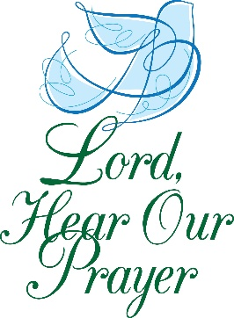
Summit Square : Ruth Quillen

Home: Mary Ultee, Mary Ann Maupin, Warner Sandquist, Polly Bare, Olive Prettyman, Nancy Hypes, Mike and Cathy Cunningham.

Friends and Family: Carolyn Hedrick-Williams (Colleen Cash), Damon Prettyman (Olive Prettyman), Jessica Faulk, Maria Costello (Cunningham).

Military: Carson Craig, Michael Little



FIRST PRESBYTERIAN CHURCH
WAYNESBORO, VIRGINIA

A community-minded congregation living out the love of Christ as we serve one another with humility, gentleness, and patience through God’s grace.

October 4, 2026 11:00 AM

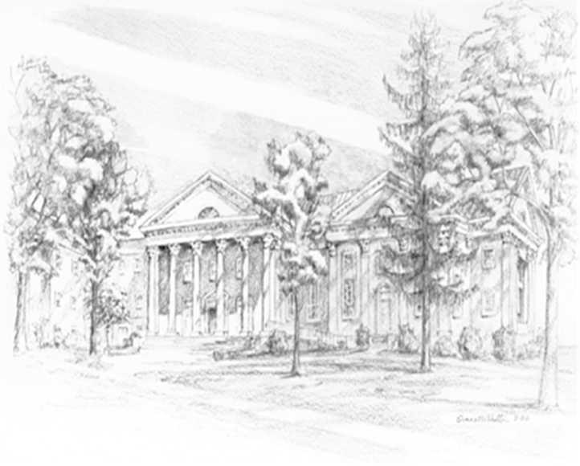

P.O. Box 877
249 South Wayne Avenue
Waynesboro, Virginia
(540) 949-8366
Church Website: www.firstpresway.org
Preschool Website: www.firstprespre.org
Email: church@firstpresway.com

