September 13, 2026 Liturgist: Terry Crickenberger

PRELUDE Prelude, Op. 31, no. 5 Vierne (1870-1937)

WELCOME & ANNOUNCEMENTS

INTROIT O Come Let Us Sing Unto the Lord Lantz III (b. 1956)
O come let us sing unto the Lord.
Let us come before His presence with joyful thanksgiving.
Sing to the Lord all those on earth. Bless His name!

CALL TO WORSHIP
Leader: We come to take our place in God’s long story;
All: we did not begin God’s work, nor will we complete it;
Leader: yet while we are here, we have a beautiful chapter to write.
All: We come to worship God, who carries us through this life
Leader: and tends our legacy long after we are gone.
All: Let us worship God!

MORNING PRAYER

*OPENING HYMN #2 Come, Thou Almighty King ITALIAN HYMN

CHILDREN’S SERMON

CALL TO CONFESSION

PRAYER OF CONFESSION
Merciful Lord, upon whom we build our life, forgive us for our sins. We have trusted in our own efforts and failed to trust in yours. We have loved control and shied away from hope.
We look to the future with fear, as if you are not already there. Rebuild our trust in you, O Lord, our Rock and our Redeemer, that we might walk in your paths and place our legacy in your hands alone. Amen.

SILENT PRAYER

ASSURANCE OF PARDON

*GLORIA PATRI #

FIRST SCRIPTURE READING Exodus 15:1b-11, 20-21 p.54

ANTHEM Reach Out and Touch Brown (b. 1942)
Randy Hypes, percussion

Reach out and touch a soul that is hungry; reach out and touch a spirit in despair;
Reach out and touch a life torn and dirty, a man who is lonely if you care!
Reach out and touch that neighbor who hates you;
Reach out and touch that stranger who meets you;
Reach out and touch the brother who needs you;
Reach out and let the smile of God touch through you.
Reach out and touch a friend who is weary; reach out and touch a seeker unaware;
Reach out and touch, though touching means losing a part of your own self if you dare!
Reach out and give your love to the loveless;
Reach out and make a home for the homeless;
Reach out and shed God’s light in the darkness;
Reach out and let the smile of God touch through you.

SECOND SCRIPTURE READING Numbers 27:12-20 p.129

SERMON A Future Not Our Own Rev. Samantha Coggins

*AFFIRMATION OF FAITH
It helps, now and then, to step back and take the long view.
The Kingdom is not only beyond our efforts; it is even beyond our vision.
We accomplish in our lifetime only a fraction of the magnificent enterprise that is God’s work.
Nothing we do is complete, which is another way of saying that the kingdom always lies beyond us.
No statement says all that could be said. No prayer fully expresses our faith. No confession brings perfection. No pastoral visit brings wholeness. No program accomplishes the church’s mission. No set of goals and objectives includes everything.
This is what we are about.
We plant the seeds that one day will grow. We water the seeds already planted, knowing that they hold future promise. We lay foundations that will need further development. We provide yeast that produces effects far beyond our capabilities.

We cannot do everything and there is a sense of liberation in realizing that. This enables us to do something and to do it well.
It may be incomplete, but it is a beginning, a step along the way, an opportunity for the Lord’s grace to enter and do the rest.
We may never see the end results, but that is the difference between the master builder and the worker.
We are workers, not master builders; ministers, not messiahs.
We are prophets of a future not our own.

PRAYERS of the PEOPLE and THE LORD’S PRAYER

*CLOSING HYMN #545 Lord, Bid Your Servant Go in Peace LAND OF REST

*BENEDICTION

POSTLUDE Concerto in G: Presto Ernst (1696-1715)/Bach (1685-1750)

This week’s Affirmation of Faith is a responsive reading of The Romero Prayer, written by Bishop Ken Untener of Saginaw, in 1979. The rest of the liturgy is written by Rev. Carol Holbrook Prickett, and her worship resource Deep Well Worship

Link: https://www.youtube.com/watch?v=buLWdc2kFZk



FIRST PRESBYTERIAN CHURCH
WAYNESBORO, VIRGINIA

A community-minded congregation living out the love of Christ as we serve one
another with humility, gentleness, and patience through God’s grace.

September 13, 2026 11:00 AM

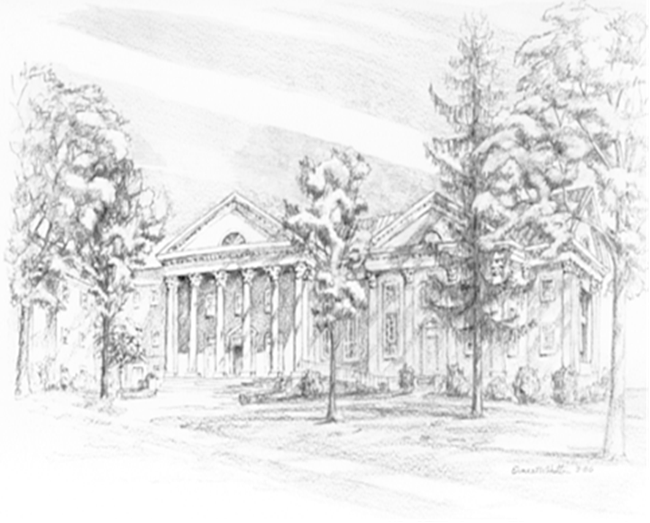

P.O. Box 877
249 South Wayne Avenue
Waynesboro, Virginia
(540) 949-8366
Church Website: www.firstpresway.org
Preschool Website: www.firstprespre.org
Email: church@firstpresway.com



Home: Mary Ultee, Mary Ann Maupin, Warner Sandquist, Polly Bare, Linda Quillen, Olive Prettyman, Nancy Hypes, Ruth & Lewis Kelley.

Friends and Family: Carolyn Hedrick-Williams (Colleen Cash), Damon Prettyman (Olive Prettyman).

Military: Carson Craig, Michael Little

Bread breakers Resumed! With the idea of promoting informal get-togethers outside church walls, Betsy Ruehl invites members and friends of First Presbyterian Church to a Potluck Dinner at her home at 5:00 Saturday, September 19. Let Betsy know what you’d like to bring to accompany a pork roast. Reservations by Wednesday the 16th (540) 942-3667 (I don’t text) or etruehl@ntelos.net. Come rain or shine to 717 Locust Avenue, Waynesboro.

Last Book Study - Wednesday, Sept. 16
We will meet to discuss the last chapters of Good Soil by Jeff Chu on Wednesday, September 16, at 10:00 a.m. in the Barksdale Room. Please bring a snack or beverage to share.

CROP Walk is Sunday, September 20
We will participate again this year in the CROP walk to end hunger, on Sunday, September 20. Join our church’s team by going to East Augusta Waynesboro CROP walk online. For more details, see the display table in the Narthex on your way out.

An offering plate is available in the narthex.

