September 20, 2026 Liturgist: Patrick Fitzgibbon

PRELUDE Divine Spirits Boëly (1785-1858)

WELCOME & ANNOUNCEMENTS

INTROIT What Does the Lord Require Routley (1917-1982)

What does the Lord require for praise and offering?
What sacrifice, desire or tribute bid you bring?
Do justly; love mercy; walk humbly with your God.

CALL TO WORSHIP
Leader: We come to worship the God of Ruth, Boaz, and Naomi;
All: ordinary people who left an extraordinary legacy.
Leader: God, you work in mysterious ways.
All: Who knows what foundation you have laid
Leader: in what we have done this week alone?
All: We trust in your plans, and we worship you!

MORNING PRAYER

*OPENING HYMN #41 O Worship the King, All Glorious Above! LYONS

CHILDREN’S SERMON

CALL TO CONFESSION

PRAYER OF CONFESSION
Merciful Lord, upon whom we build our life, forgive us for our sins.
We have discounted what is small, confused faith with futility, and ignored where
our ordinary stories intersect with your eternal story. Give us the trust to commit ourselves
to acts of ordinary faithfulness without knowing where they may lead but trusting that you will make good. We pray in the name of Jesus Christ, our Rock and our Redeemer. Amen.

SILENT PRAYER

ASSURANCE OF PARDON

*GLORIA PATRI #581 Glory Be to the Father GLORIA PATRI

FIRST SCRIPTURE READING Exodus 16:9-15 p.55

ANTHEM Hear My Words Paulus (1949-2014)

Hear my words, O gracious Lord, to my thoughts attentive be;
Hear my cry, my King my God, I will make my prayer to Thee.

With the morning light, O Lord, Thou shalt hear my voice arise;
And expectant, I will bring prayer as morning sacrifice.

Thou art Holy, O my God; Thou delightest not in sin;
Evil shall not dwell with Thee, nor the proud Thy favor win.

SECOND SCRIPTURE READING Ruth 4:9-17 p.212

SERMON Our Ancestors’ Faithfulness Rev. Samantha Coggins

*AFFIRMATION OF FAITH
What is my only comfort in life and in death?
That I am not my own, but belong—body and soul, in life and in death—
to my faithful Savior, Jesus Christ.
He has fully paid for all my sins with his precious blood, and has set me free
from the tyranny of evil.
He also watches over me in such a way that not a hair can fall from my head
without the will of my Father in heaven; in fact, all things must work together for my salvation.
Because I belong to him, Christ, by his Holy Spirit, assures me of eternal life
and makes me wholeheartedly willing and ready from now on to live for him.

PRAYERS of the PEOPLE and THE LORD’S PRAYER

*CLOSING HYMN #65 Guide Me, O Thou Great Jehovah CWM RHONNDA

*BENEDICTION

POSTLUDE Prelude and Fugue in C attr. Fischer (1656-1746)

This week’s liturgy was written by Rev. Carol Holbrook Prickett, via her online liturgy resource Deep Well Worship. It is from her Legacy sermon series.

The Affirmation of Faith is an excerpt from The Heidelberg Catechism (section 4.001), which was written in 1562 to reconcile different theological perspectives within various groups of the Reformation. It is written in question and answer form so that it can be memorized. This catechism was brought to America by the pilgrims and remains influential for American faith.

Link: https://www.youtube.com/watch?v=sHe9S2TxwoA



Home: Mary Ultee, Mary Ann Maupin, Warner Sandquist, Polly Bare, Linda Quillen, Olive Prettyman, Nancy Hypes, Ruth & Lewis Kelley.

Friends and Family: Carolyn Hedrick-Williams (Colleen Cash), Damon Prettyman (Olive Prettyman).

Military: Carson Craig, Michael Little

Better Together Bible Study is cancelled for Monday, September 21.

FIRST PRESBYTERIAN CHURCH
WAYNESBORO, VIRGINIA

A community-minded congregation living out the love of Christ as we serve one
another with humility, gentleness, and patience through God’s grace.

September 20, 2026 11:00 AM

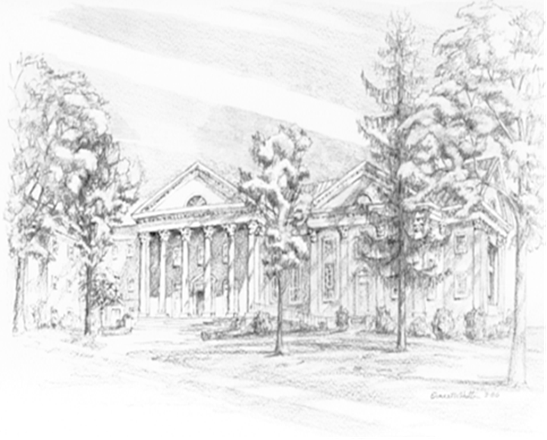

P.O. Box 877
249 South Wayne Avenue
Waynesboro, Virginia
(540) 949-8366
Church Website: www.firstpresway.org
Preschool Website: www.firstprespre.org
Email: church@firstpresway.com

