September 27, 2026 Liturgist: Betsy Ruehl

PRELUDE Suite in d: Duo, Trio Clérambault (1676-1749)

WELCOME & ANNOUNCEMENTS

INTROIT Rejoice, Ye Pure in Heart Dirksen (1921-2003)

Rejoice, ye pure in heart! Rejoice, give thanks and sing!
Your festal banner wave on high, the cross of Christ our King!

CALL TO WORSHIP
Leader: We come to offer what we have:
All: an hour of time, the beauty of our singing,
Leader: the offering from our pockets, the prayers of our hearts.
All: All: Sometimes it doesn’t feel like enough.
Leader: And yet, may we be remembered this way:
All: we are people who revere something bigger than ourselves.
Leader: Friends, you are enough.
All: Let us worship God with all we are!

MORNING PRAYER

*OPENING HYMN #396 Brethren, We Have Met to Worship HOLY MANNA

CHILDREN’S SERMON

CALL TO CONFESSION

PRAYER OF CONFESSION
Merciful Lord, upon whom we build our life, forgive us for our sins.
We hoard what we have and are frightened of giving too much.
We are quick to judgment and slow to generosity.
We neglect to tell the stories of the saints, and even more, to live lives like theirs.
Break open our closed fists, that we may hold our hands up in praise of you, Jesus Christ,
our Rock and Redeemer. Amen.

SILENT PRAYER
ASSURANCE OF PARDON

*GLORIA PATRI #581 Glory Be to the Father GLORIA PATRI

FIRST SCRIPTURE READING Psalm 78:1-4, 12-16 p.468

ANTHEM Go Ye Into All the World Butler (1935-2024)
Randy Hypes, percussion

Go ye into all the world and preach My gospel to every creature!
Jesus said, “This is the great commandment:
That you love one another as I have loved you.
Greater love hath no man than this;
That he lay down his life for his friends.”
“Let not your heart be troubled, you believe in God,
If you believe in God, you believe in Me!”

SECOND SCRIPTURE READING Matthew 26:6-13 p.808

SERMON As If From the Deep Itself Rev. Samantha Coggins

*AFFIRMATION OF FAITH The Apostles' Creed Hymnal p.35

PRAYERS of the PEOPLE and THE LORD’S PRAYER

*CLOSING HYMN #610 O for a Thousand Tongues to Sing AZMON

*BENEDICTION

POSTLUDE Suite in d: Grand Plein Jeu Clérambault

This week’s liturgy was written by Rev. Carol Holbrook Prickett, via her online liturgy resource Deep Well Worship. It is from her Legacy sermon series.

This week’s morning prayer was written by Diana Garibay of Sacramento, CA, age 17, published in the youth prayers in the Common English Bible (Student Edition) in 2015.

Link: https://www.youtube.com/watch?v=obV5iZovEC4



Home: Mary Ultee, Mary Ann Maupin, Warner Sandquist, Polly Bare, Linda Quillen, Olive Prettyman, Nancy Hypes, Ruth & Lewis Kelley.

Friends and Family: Carolyn Hedrick-Williams (Colleen Cash), Damon Prettyman (Olive Prettyman).

Military: Carson Craig, Michael Little

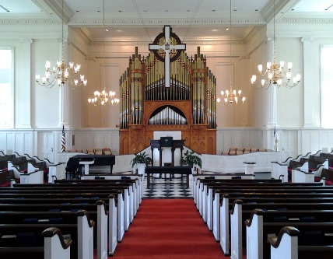
First Fridays Resume in October!

You are cordially invited to the next First Friday Organ Recital and Light Luncheon on Friday 2 October at First Presbyterian Church in Waynesboro. Beginning at 12:15, Director of Music/Organist Roger Daggy will play a program highlighting the myriad aural delights of the 1893 Woodberry and Harris organ, followed by a light luncheon served in the Barksdale Room.

FIRST PRESBYTERIAN CHURCH
WAYNESBORO, VIRGINIA

A community-minded congregation living out the love of Christ as we serve one
another with humility, gentleness, and patience through God’s grace.

September 27, 2026 11:00 AM

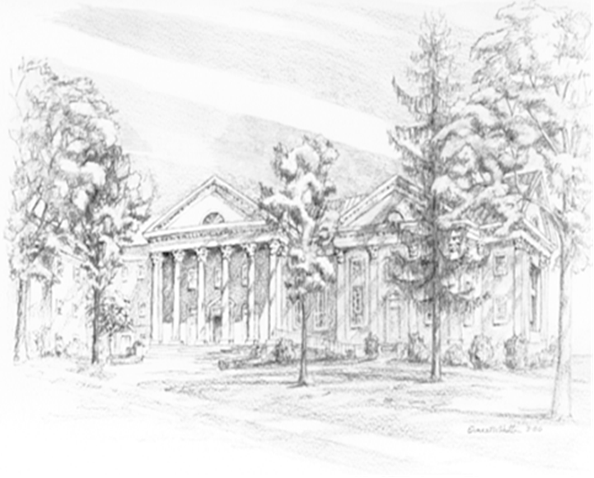

P.O. Box 877
249 South Wayne Avenue
Waynesboro, Virginia
(540) 949-8366
Church Website: www.firstpresway.org
Preschool Website: www.firstprespre.org
Email: church@firstpresway.com

