September 6, 2026 Liturgist: Samantha Coggins

PRELUDE Variations I, II Sweelinck (1562-1621)

WELCOME & ANNOUNCEMENTS

INTROIT Alleluia Milburn (b. 1963)

Alleluia! Sing to the Lord and bless His name!
Proclaim the good news of salvation from day to day! Alleluia!

CALL TO WORSHIP
Leader: Teach me, O Lord, the way of your statutes,
All: and I will observe it to the end.
Leader: Give me understanding, that I may keep your law
All: and observe it with my whole heart.
Leader: Lead me in the path of your commandments,
All: for I delight in it.
Leader: Turn my heart to your decrees;
All: in your righteousness, be gracious to me.

MORNING PRAYER

*OPENING HYMN #550 Give Thanks to the Lord LAUDATE DOMINUM

CHILDREN’S SERMON

CALL TO CONFESSION

PRAYER OF CONFESSION
Lord God, we have judged others harshly, unfairly and casually. We tend to focus on the sin, brokenness and foibles of others, rather than on the growth and work we are called to. We’ve made assumptions about what others want and need, robbing them of the freedom to speak for themselves. We’ve tuned out the voices bold enough to express views that are different from ours. We’ve relied upon your grace, time and time again, while hastily denying that you are eager to give it not only to us, but to our enemies, also. Help us to see others as you see them; help us to see you with faith and trust.

SILENT PRAYER

ASSURANCE OF PARDON

*GLORIA PATRI #581 Glory Be to the Father GLORIA PATRI

FIRST READING Psalm 149 p.508

ANTHEM The Disciples Knew the Lord Jesus Milburn
Maximilian Daggy, baritone

Refrain: The disciples knew the Lord Jesus in the breaking of the bread.
The bread which we break, alleluia, is the communion of the body of Christ. (Refrain)
One body are we, alleluia, though we are many we share one cup. (Refrain)

SECOND READING Acts 8:26-40 p.892

SERMON Look! Water! Rev. Samantha Coggins

ORDINATION AND INSTALLATION OF RULING ELDERS
Mike Cunningham Nancy Hypes Janet Shaner

THE LORD’S SUPPER
Invitation
Great Thanksgiving
Communion of the People

*CLOSING HYMN #611 Joyful, Joyful, We Adore Thee HYMN TO JOY

*BENEDICTION

POSTLUDE Variations IV Sweelinck

LINK: https://www.youtube.com/watch?v=aQbzXK54_6k

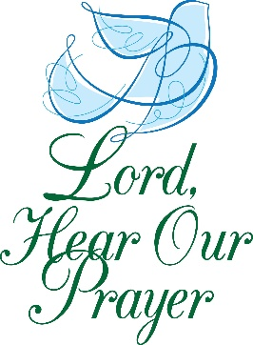
Summit Square : Ruth Quillen

Home: Mary Ultee, Mary Ann Maupin, Warner Sandquist, Polly Bare, Olive Prettyman, Nancy Hypes, Mike and Cathy Cunningham.

Friends and Family: Carolyn Hedrick-Williams (Colleen Cash), Damon Prettyman (Olive Prettyman), Jessica Faulk, Maria Costello (Cunningham).

Military: Carson Craig, Michael Little



Jeffrey Clark, friend of our church, passed away suddenly on Monday evening (August 31) at Augusta Hospital. Jeff lived at Springdale and attended worship at First Presbyterian on Sundays many times, sharing generously and openly about his faith and God’s healing in his life. Using a scooter to get around, as he needed an oxygen tank for his breathing and heart, Jeff blessed our congregation with warmth and testimony. Please bear up in prayer Jeff’s sister, Joyce Clerico; Joyce’s husband, Jim Clerico; and Jeff's son, Frankie Clark, as they grieve the loss of their brother, brother-in-law, and father.

Ordination & Installation of Ruling Elders
Today in worship, we ordain and install ruling elders to serve our Session, the church’s governing board. We ordain and install Janet Shaner; we install Mike Cunningham and Nancy Hypes. We rejoice at their ongoing call to leadership and service!

CROP Walk is Sunday, September 20
We will participate again this year in the CROP walk to end hunger, on Sunday, September 20. Join our church’s team by going to East Augusta Waynesboro CROP walk online. For more details, see the display table in the Narthex on your way out.

FIRST PRESBYTERIAN CHURCH
WAYNESBORO, VIRGINIA

A community-minded congregation living out the love of Christ as we serve one another with humility, gentleness, and patience through God’s grace.

September 6, 2026 11:00 AM

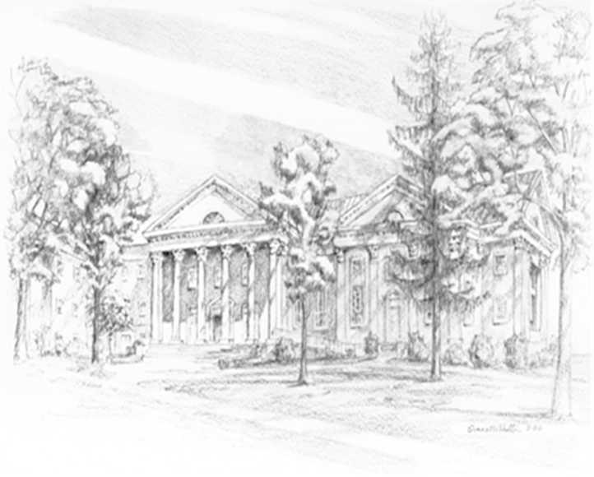

P.O. Box 877
249 South Wayne Avenue
Waynesboro, Virginia
(540) 949-8366
Church Website: www.firstpresway.org
Preschool Website: www.firstprespre.org
Email: church@firstpresway.com

